Experiment No. 1

- Experiment Title: Demonstrate Inline,Internal,External JavaScript, use console methods; create a webpage showing user info and a welcome message.
- Software/Tools Required: VS Code, Html/JS Compiler…
- Experiment Program Code:
Internal:
<!DOCTYPE html>
<html>
<head>
<title>Hello World</title>

<style>
body{
background-color:#ffe4e1;
text-align:center;
font-family:Arial, sans-serif;
padding:40px;
}

h1{
font-size:48px;
color:white;
background-color:#91ff00;
padding:15px;
border-radius:8px;
}

p{
font-size:20px;
color:#333333;
background-color:#ffffcc;
padding:10px;
margin-top:20px;
}

button{
font-size:18px;
color:white;
background-color:green;
padding:12px 24px;
border:none;
border-radius:5px;
cursor:pointer;
margin-top:20px;
}
</style>

</head>
<body>

<h1>Hello World</h1>
<p>Name :Saksham Chimdyalwar, PRN : 24070521151</p>

<p>This is a sample Webpage made using Internal css.</p>

<button>Click Me</button>

</body>
</html>

External:
<!DOCTYPE html>
<html>
<head>
<title>Hello World</title>
<link rel="stylesheet" href="style.css">
</head>
<body>

<h1>Hello World</h1>
<p> Name :Saksham Chimdyalwar, PRN: 24070521151</p>
<p> Sec: C, Sem: 5th </p>

<p>This is a sample Webpage is made by using the External CSS.</p>

<button>Click Me</button>

</body>
</html>

Inline:
<!DOCTYPE html>
<html>
<head>
<title>Hello World</title>
</head>
<body style="background-color:#f0f8ff; text-align:center; font-family:Arial, sans-serif; padding:40px;">

<h1 style="font-size:48px; color:white; background-color:#007BFF; padding:15px; border-radius:8px;">
Hello World
</h1>
<p>
Name : Saksham Chimdyalwar,PRN : 24070521151
</p>
<p style="font-size:20px; color:#333333; background-color:#ffffcc; padding:10px; margin-top:20px;">

This is a sample webpage designed by Inline CSS.
</p>

<button style="font-size:18px; color:white; background-color:green; padding:12px 24px; border:none; border-radius:5px; cursor:pointer; margin-top:20px;">
Click Me
</button>
</body>
</html>
- Output:
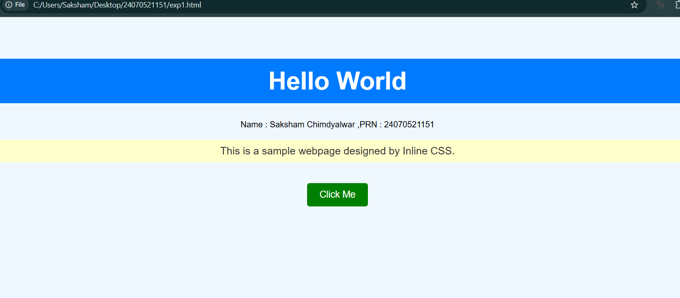

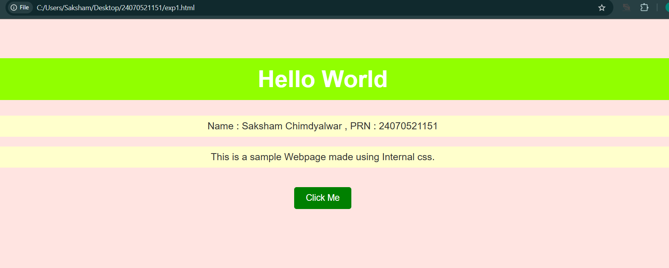

Case Study 1
- Case Study Title: Designing a webpage for SIT Nagpur with buttons , text , images, etc.…
- Case Study Program Code:
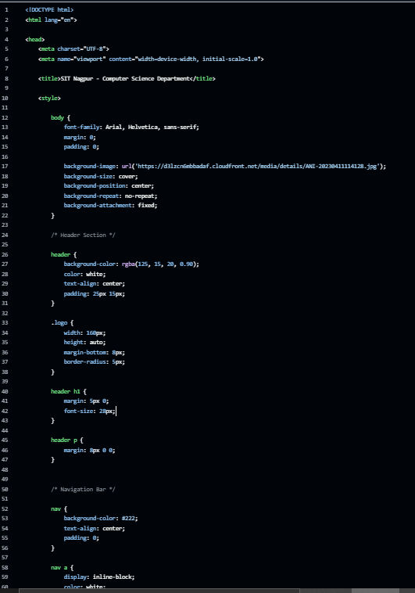

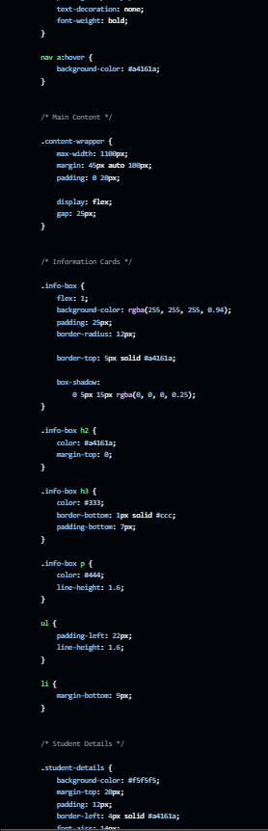

3.Output



Experiment No. 2

- Experiment Title: Use var,let,const and demonstrate basic festures like template literals and destructing; build a billing calculator with user input.
- Software/Tools Required: VS Code, Html/JS Compiler…
- Experiment Program Code:
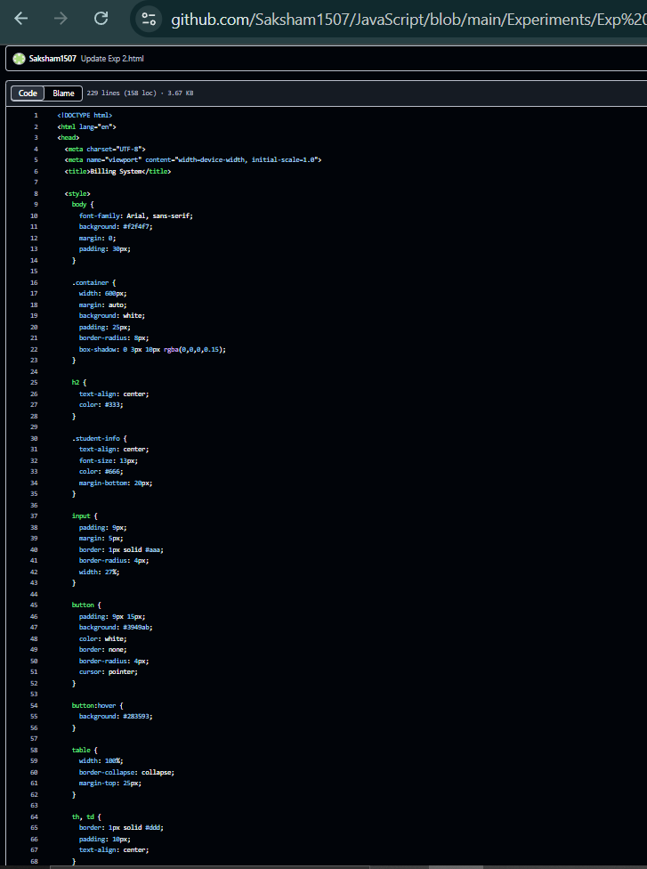

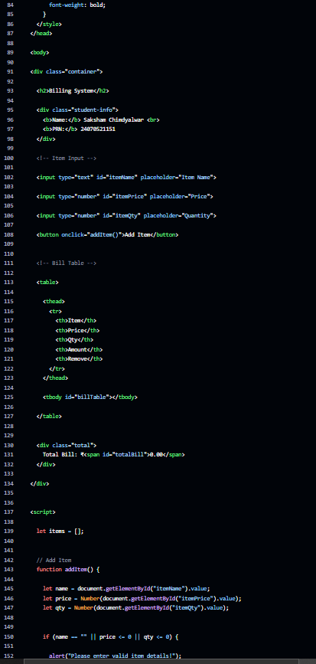

4.Output:

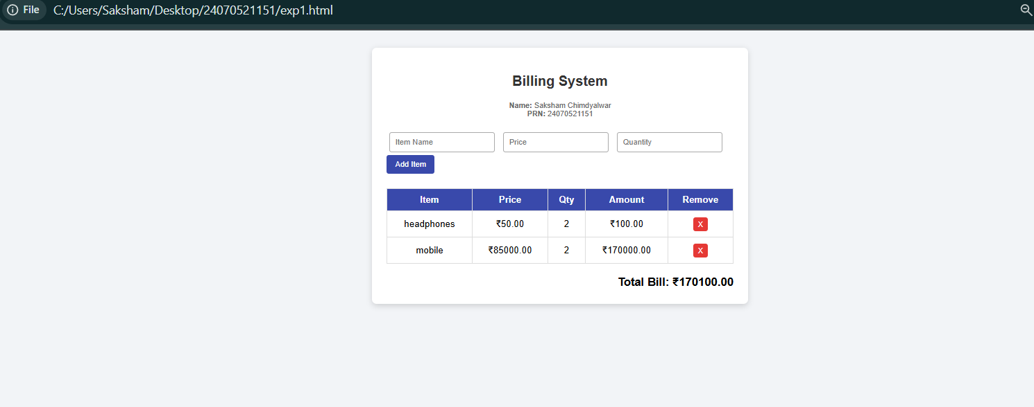

Case Study 2
- Case Study Title: Develop the webpage for an online shopping website using html, css js .

- Case Study Program Code:
<!DOCTYPE html>
<html lang="en">
<head>
<meta charset="UTF-8">
<meta name="viewport" content="width=device-width, initial-scale=1.0">
<title>Online Shopping</title>

<style>
* { box-sizing: border-box; margin: 0; padding: 0; font-family: Arial, sans-serif; }

body { display: flex; min-height: 100vh; background: #eef2f5; }

.products-section { flex: 2; padding: 25px; }
.cart-section { flex: 1; padding: 25px; background: white; border-left: 2px solid #bbb; }

h2 { margin-bottom: 18px; color: #222; }

.student {
margin-bottom: 20px;
font-size: 13px;
color: #555;
}

.grid {
display: grid;
grid-template-columns: repeat(auto-fill, minmax(180px, 1fr));
gap: 18px;
}

.card {
background: white;
padding: 18px;
border-radius: 6px;
border: 1px solid #ccc;
text-align: center;
}

.card h3 { margin-bottom: 8px; }

.price {
color: #7b1fa2;
font-weight: bold;
margin-bottom: 12px;
}

button {
background: #7b1fa2;
color: white;
border: none;
padding: 8px 12px;
border-radius: 4px;
cursor: pointer;
}

button:hover { background: #6a1b9a; }

table {
width: 100%;
border-collapse: collapse;
margin-bottom: 20px;
}

th, td {
text-align: left;
padding: 8px;
border-bottom: 1px solid #ddd;
}

.remove-btn {
background: #e53935;
padding: 4px 8px;
}

.total-box {
font-size: 18px;
font-weight: bold;
display: flex;
justify-content: space-between;
margin-top: 15px;
}

.checkout-btn {
width: 100%;
padding: 10px;
background: #388e3c;
margin-top: 15px;
}

.checkout-btn:hover { background: #2e7d32; }
</style>
</head>

<body>

<!-- PRODUCTS -->
<section class="products-section">

<h2>Online Shopping Store</h2>

<div class="student">
<b>Name:</b> Saksham Chimdyalwar <br>
<b>PRN:</b> 24070521151
</div>

<div class="grid" id="productGrid"></div>

</section>

<!-- CART -->
<section class="cart-section">

<h2>My Cart</h2>

<table>
<thead>
<tr>
<th>Product</th>
<th>Qty</th>
<th>Price</th>
<th></th>
</tr>
</thead>

<tbody id="cartTable"></tbody>
</table>

<div class="total-box">
<span>Total:</span>
<span id="grandTotal">₹0.00</span>
</div>

<button class="checkout-btn" onclick="checkout()">
Place Order
</button>

</section>

<script>

// Product List
const products = [
{ id: 1, name: "Wireless Mouse", price: 1428.00 },
{ id: 2, name: "Keyboard", price: 2856.00 },
{ id: 3, name: "Headphones", price: 4284.00 },
{ id: 4, name: "USB Cable", price: 761.60 }
];

let cart = [];

// Display Products
function renderProducts() {

const grid = document.getElementById("productGrid");

grid.innerHTML = products.map(p => `
<div class="card">
<h3>${p.name}</h3>
<p class="price">₹${p.price.toFixed(2)}</p>
<button onclick="addToCart(${p.id})">Add Item</button>
</div>
`).join('');

}

// Add Item
function addToCart(productId) {

const item = cart.find(i => i.id === productId);

if (item) {
item.qty++;
}
else {
const product = products.find(p => p.id === productId);
cart.push({ ...product, qty: 1 });
}

renderCart();
}

// Remove Item
function removeFromCart(productId) {

cart = cart.filter(i => i.id !== productId);

renderCart();
}

// Display Cart
function renderCart() {

const table = document.getElementById("cartTable");
const totalEl = document.getElementById("grandTotal");

if (cart.length === 0) {

table.innerHTML =
`<tr><td colspan="4" style="text-align:center; color:#777;">No items in cart</td></tr>`;

totalEl.textContent = "₹0.00";

return;
}

table.innerHTML = cart.map(i => `
<tr>
<td>${i.name}</td>
<td>${i.qty}</td>
<td>₹${(i.price * i.qty).toFixed(2)}</td>
<td>
<button class="remove-btn"
onclick="removeFromCart(${i.id})">X</button>
</td>
</tr>
`).join('');

const total = cart.reduce(
(sum, item) => sum + (item.price * item.qty), 0
);

totalEl.textContent = `₹${total.toFixed(2)}`;
}

// Checkout
function checkout() {

if (cart.length === 0) {
alert("Cart is empty!");
return;
}

alert("Order placed successfully!");

cart = [];

renderCart();
}

renderProducts();
renderCart();

</script>

</body>
</html>

3.Output:

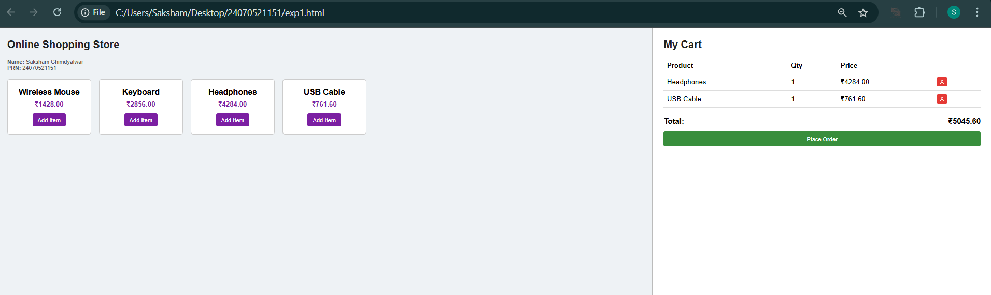

Experiment No. 3

- Experiment Title: Implement control structures and form validations; create a grading system based on user-entered marks.
- Software/Tools Required: VS Code, Html/JS Compiler…
- Experiment Program Code:
- <!DOCTYPE html>
- <html lang="en">
- <head>
- <meta charset="UTF-8">
- <meta name="viewport" content="width=device-width, initial-scale=1.0">
- <title>Student Grade Calculator</title>

- <style>
- * {
- box-sizing: border-box;
- font-family: Arial, sans-serif;
- }

- body {
- margin: 0;
- min-height: 100vh;
- display: flex;
- justify-content: center;
- align-items: center;
- background-color: #eef2f7;
- }

- .container {
- width: 430px;
- background-color: white;
- padding: 30px;
- border-radius: 12px;
- box-shadow: 0 5px 18px rgba(0,0,0,0.15);
- }

- h2 {
- text-align: center;
- color: #222;
- margin-top: 0;
- }

- .student {
- text-align: center;
- font-size: 13px;
- color: #555;
- margin-bottom: 20px;
- }

- label {
- display: block;
- margin-top: 12px;
- margin-bottom: 5px;
- font-weight: bold;
- }

- input {
- width: 100%;
- padding: 9px;
- border: 1px solid #aaa;
- border-radius: 5px;
- }

- button {
- width: 100%;
- margin-top: 20px;
- padding: 11px;
- background-color: #3949ab;
- color: white;
- border: none;
- border-radius: 6px;
- font-size: 16px;
- cursor: pointer;
- }

- button:hover {
- background-color: #303f9f;
- }

- #result {
- display: none;
- margin-top: 20px;
- padding: 15px;
- border-radius: 7px;
- background-color: #e8f5e9;
- line-height: 1.7;
- }

- .fail {
- background-color: #ffebee !important;
- }
- </style>
- </head>

- <body>

- <div class="container">

- <h2>Student Grade Calculator</h2>

- <div class="student">
- <b>Name:</b> Saksham Chimdyalwar |
- <b>PRN:</b> 24070521151
- </div>

- <label>Mathematics</label>
- <input type="number" id="math" placeholder="Enter marks (0-100)">

- <label>Science</label>
- <input type="number" id="science" placeholder="Enter marks (0-100)">

- <label>English</label>
- <input type="number" id="english" placeholder="Enter marks (0-100)">

- <label>History</label>
- <input type="number" id="history" placeholder="Enter marks (0-100)">

- <label>Computer Science</label>
- <input type="number" id="computer" placeholder="Enter marks (0-100)">

- <button onclick="calculateGrade()">Calculate Result</button>

- <div id="result"></div>

- </div>

- <script>

- function calculateGrade() {

- let math = Number(document.getElementById("math").value);
- let science = Number(document.getElementById("science").value);
- let english = Number(document.getElementById("english").value);
- let history = Number(document.getElementById("history").value);
- let computer = Number(document.getElementById("computer").value);

- let marks = [math, science, english, history, computer];

- // Validate marks
- for (let i = 0; i < marks.length; i++) {

- if (marks[i] < 0 || marks[i] > 100) {
- alert("Marks must be between 0 and 100.");
- return;
- }
- }

- let total = math + science + english + history + computer;

- let percentage = total / 5;

- let grade;
- let status = "PASS";

- // Check if student failed any subject
- let failed = false;

- for (let i = 0; i < marks.length; i++) {
- if (marks[i] < 40) {
- failed = true;
- }
- }

- if (failed) {

- grade = "F";
- status = "FAIL";

- } else if (percentage >= 90) {

- grade = "A+";

- } else if (percentage >= 80) {

- grade = "A";

- } else if (percentage >= 70) {

- grade = "B";

- } else if (percentage >= 60) {

- grade = "C";

- } else if (percentage >= 50) {

- grade = "D";

- } else {

- grade = "F";
- status = "FAIL";
- }

- let resultBox = document.getElementById("result");

- resultBox.innerHTML =
- "<b>Name:</b> Saksham Chimdyalwar<br>" +
- "<b>PRN:</b> 24070521151<br><br>" +
- "<b>Total Marks:</b> " + total + " / 500<br>" +
- "<b>Percentage:</b> " + percentage.toFixed(2) + "%<br>" +
- "<b>Grade:</b> " + grade + "<br>" +
- "<b>Status:</b> " + status;

- resultBox.style.display = "block";

- if (status === "FAIL") {
- resultBox.classList.add("fail");
- } else {
- resultBox.classList.remove("fail");
- }
- }

- </script>

- </body>
- </html>

4.Output:

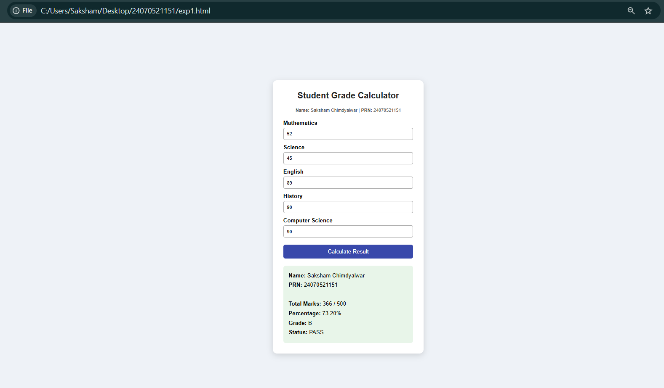

Case Study 3
- Case Study Title: Desing a webpage that match password with the user password, if matched it displays result, if not result not displayed.
- Case Study Program Code:
- <!DOCTYPE html>
- <html lang="en">
- <head>
- <meta charset="UTF-8">
- <meta name="viewport" content="width=device-width, initial-scale=1.0">
- <title>Student Result Portal</title>

- <style>
- * {
- box-sizing: border-box;
- margin: 0;
- padding: 0;
- font-family: Arial, sans-serif;
- }

- body {
- display: flex;
- min-height: 100vh;
- background: #f2f4f7;
- }

- /* Left Section */
- .section-left {
- flex: 1;
- padding: 40px 20px;
- background: white;
- border-right: 2px solid #ccc;
- display: flex;
- justify-content: center;
- align-items: center;
- }

- /* Right Section */
- .section-right {
- flex: 1;
- padding: 40px 20px;
- background: #eef2ff;
- display: flex;
- justify-content: center;
- align-items: center;
- }

- .box {
- width: 100%;
- max-width: 320px;
- }

- h2 {
- margin-bottom: 20px;
- color: #333;
- }

- .student-info {
- font-size: 13px;
- color: #666;
- margin-bottom: 20px;
- line-height: 1.6;
- }

- label {
- display: block;
- font-weight: bold;
- margin-bottom: 8px;
- }

- input {
- width: 100%;
- padding: 10px;
- border: 1px solid #aaa;
- border-radius: 5px;
- font-size: 16px;
- margin-bottom: 15px;
- }

- button {
- width: 100%;
- padding: 10px;
- background: #5e35b1;
- color: white;
- border: none;
- border-radius: 5px;
- font-size: 16px;
- cursor: pointer;
- }

- button:hover {
- background: #4527a0;
- }

- .error {
- color: #b71c1c;
- background: #ffcdd2;
- padding: 8px;
- border-radius: 5px;
- margin-top: 12px;
- display: none;
- text-align: center;
- }

- .placeholder {
- color: #666;
- font-size: 16px;
- }

- /* Result Box */
- .result-card {
- display: none;
- background: white;
- border: 2px solid #43a047;
- border-radius: 10px;
- padding: 30px;
- text-align: center;
- width: 260px;
- }

- .status {
- background: #c8e6c9;
- color: #1b5e20;
- padding: 5px 15px;
- border-radius: 10px;
- font-weight: bold;
- display: inline-block;
- margin-bottom: 15px;
- }

- .gpa {
- font-size: 45px;
- font-weight: bold;
- color: #5e35b1;
- }

- .label {
- color: #555;
- font-size: 14px;
- font-weight: bold;
- }
- </style>
- </head>

- <body>

- <!-- LEFT SIDE -->
- <div class="section-left">

- <div class="box">

- <h2>Student Result Login</h2>

- <div class="student-info">
- <b>Name:</b> Saksham Chimdyalwar<br>
- <b>PRN:</b> 24070521151
- </div>

- <form id="loginForm">

- <label>Password</label>

- <input
- type="text"
- id="passInput"
- placeholder="Enter your password"
- required
- >

- <button type="submit">View Result</button>

- </form>

- <div id="errorMsg" class="error">
- Wrong Password!
- </div>

- </div>

- </div>

- <!-- RIGHT SIDE -->
- <div class="section-right">

- <div id="placeholder" class="placeholder">
- Enter correct password to view your result
- </div>

- <div id="resultCard" class="result-card">

- <span class="status">PASS</span>

- <div class="gpa">9</div>

- <div class="label">GPA</div>

- </div>

- </div>

- <script>

- const TARGET_PASS = "Saksham1151";

- document.getElementById("loginForm").addEventListener("submit", function(e) {

- e.preventDefault();

- const inputVal =
- document.getElementById("passInput").value.trim();

- const isCorrect = (inputVal === TARGET_PASS);

- document.getElementById("errorMsg").style.display =
- isCorrect ? "none" : "block";

- document.getElementById("resultCard").style.display =
- isCorrect ? "block" : "none";

- document.getElementById("placeholder").style.display =
- isCorrect ? "none" : "block";

- });

- </script>

- </body>
- </html>

3.Output:

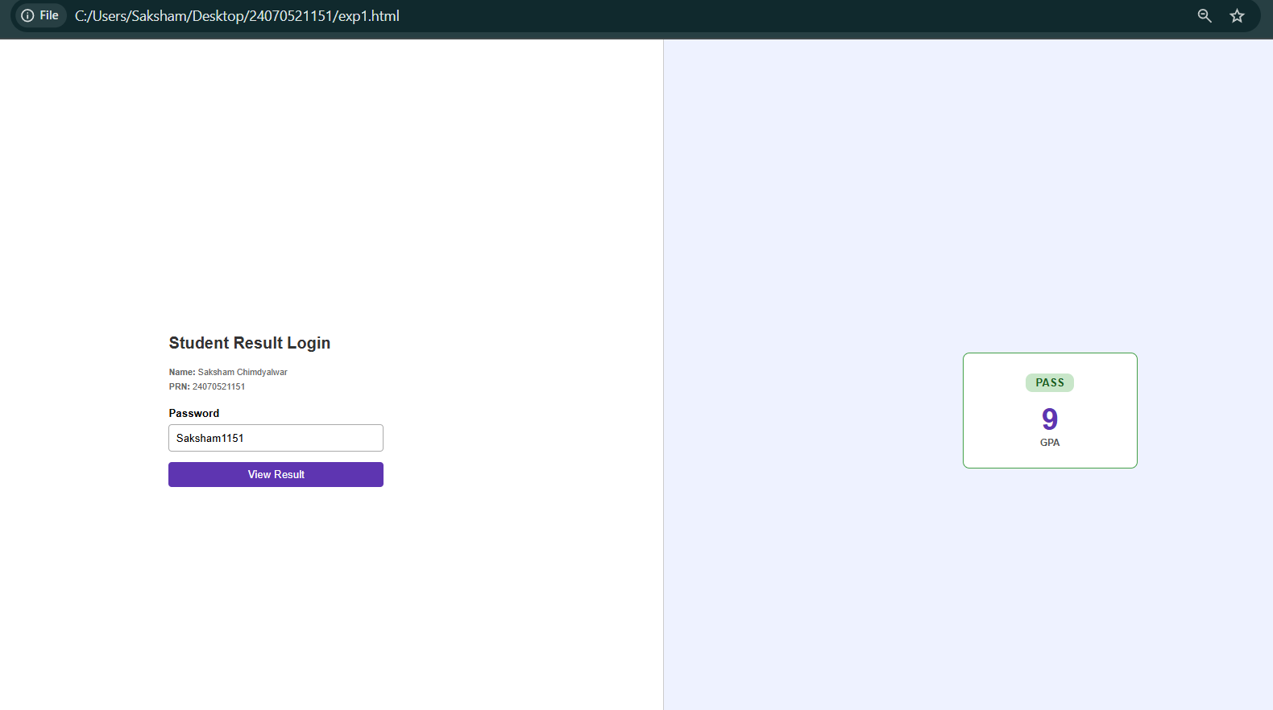

Experiment No. 4

- Experiment Title: Use Function types, scope, and closures; apply try and catch; build a palindrome checker.
- Software/Tools Required: VS Code, Html/JS Compiler…
- Experiment Program Code:
<!DOCTYPE html>
<html lang="en">

<head>
<meta charset="UTF-8">
<meta name="viewport" content="width=device-width, initial-scale=1.0">

<title>Palindrome Finder</title>

<style>
body {
font-family: Arial, sans-serif;
background-color: #eaf2f8;
display: flex;
justify-content: center;
align-items: center;
height: 100vh;
margin: 0;
}

.box {
background-color: white;
width: 400px;
padding: 30px;
border-radius: 10px;
box-shadow: 0 5px 15px rgba(0,0,0,0.15);
text-align: center;
}

h2 {
margin-top: 0;
color: #222;
}

.info {
font-size: 13px;
color: #666;
margin-bottom: 20px;
}

input {
width: 100%;
padding: 11px;
margin-bottom: 15px;
border: 1px solid #aaa;
border-radius: 5px;
font-size: 15px;
}

button {
width: 100%;
padding: 11px;
background-color: #3949ab;
color: white;
border: none;
border-radius: 5px;
font-size: 16px;
cursor: pointer;
}

button:hover {
background-color: #283593;
}

#answer {
margin-top: 20px;
padding: 12px;
border-radius: 6px;
display: none;
font-weight: bold;
}

.correct {
background-color: #d4edda;
color: #155724;
}

.wrong {
background-color: #f8d7da;
color: #721c24;
}
</style>

</head>

<body>

<div class="box">

<h2>Palindrome Checker</h2>

<div class="info">
Name: <b>Saksham Chimdyalwar</b><br>
PRN: <b>24070521151</b>
</div>

<input
type="text"
id="textInput"
placeholder="Enter a word or number"
>

<button onclick="findPalindrome()">
Check Palindrome
</button>

<div id="answer"></div>

</div>

<script>

function findPalindrome() {

let text = document.getElementById("textInput").value;

let answer = document.getElementById("answer");

// Check empty input
if (text === "") {

answer.style.display = "block";
answer.className = "wrong";
answer.innerHTML = "Please enter a word or number.";

return;
}

// Convert input into lowercase
let original = text.toLowerCase();

// Remove spaces
original = original.replace(/\s/g, "");

// Reverse the input
let reversed = original
.split("")
.reverse()
.join("");

// Check palindrome
if (original === reversed) {

answer.style.display = "block";
answer.className = "correct";

answer.innerHTML =
'"' + text + '" is a Palindrome!';

} else {

answer.style.display = "block";
answer.className = "wrong";

answer.innerHTML =
'"' + text + '" is NOT a Palindrome.';
}
}

</script>

</body>
</html>
4.Output;

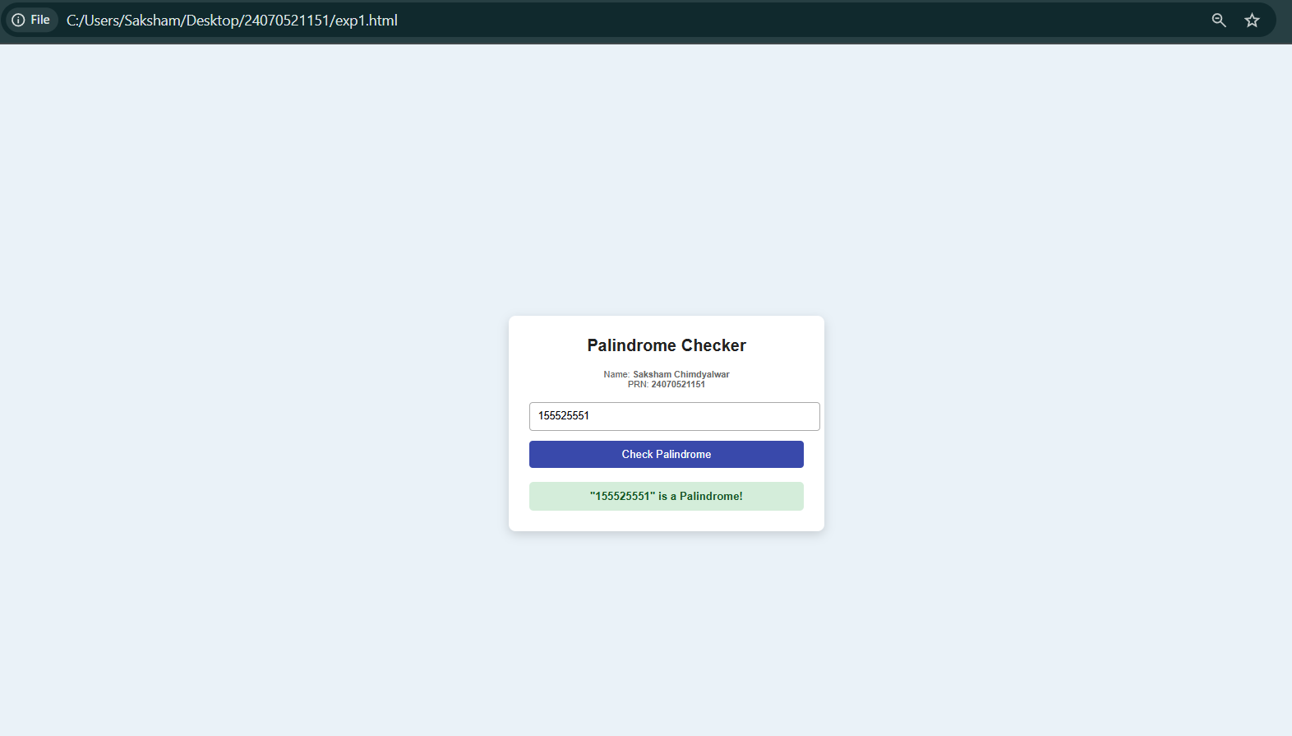

Case Study 4
- Case Study Title: Desing a webpage to check whether the password is Palindrome or not if Palindrome display msg Weak Pass if not display Strong Pass.
- Case Study Program Code:
- <!DOCTYPE html>
- <html lang="en">
- <head>
- <meta charset="UTF-8">
- <meta name="viewport" content="width=device-width, initial-scale=1.0">

- <title>Password Strength Checker</title>

- <style>
- * {
- box-sizing: border-box;
- margin: 0;
- padding: 0;
- font-family: Arial, sans-serif;
- }

- body {
- background: #eef2f5;
- display: flex;
- justify-content: center;
- align-items: center;
- min-height: 100vh;
- }

- .container {
- background: white;
- width: 400px;
- padding: 25px;
- border-radius: 8px;
- border: 1px solid #ccc;
- box-shadow: 0 4px 10px rgba(0,0,0,0.1);
- }

- h2 {
- text-align: center;
- color: #333;
- margin-bottom: 5px;
- }

- .subtitle {
- text-align: center;
- color: #777;
- font-size: 14px;
- margin-bottom: 20px;
- }

- .student-info {
- background: #f5f5f5;
- padding: 8px;
- margin-bottom: 15px;
- font-size: 13px;
- text-align: center;
- }

- .password-box {
- display: flex;
- gap: 5px;
- margin-bottom: 12px;
- }

- input {
- flex: 1;
- padding: 10px;
- border: 1px solid #aaa;
- border-radius: 5px;
- font-size: 15px;
- }

- .show-btn {
- background: #555;
- color: white;
- border: none;
- border-radius: 5px;
- padding: 8px;
- cursor: pointer;
- }

- .check-btn {
- width: 100%;
- padding: 10px;
- background: #3949ab;
- color: white;
- border: none;
- border-radius: 5px;
- cursor: pointer;
- font-size: 15px;
- }

- .check-btn:hover {
- background: #283593;
- }

- #result {
- display: none;
- margin-top: 15px;
- padding: 10px;
- text-align: center;
- border-radius: 5px;
- }

- .warning {
- display: block !important;
- background: #fff3cd;
- color: #856404;
- }

- .success {
- display: block !important;
- background: #d4edda;
- color: #155724;
- }

- .error {
- display: block !important;
- background: #f8d7da;
- color: #721c24;
- }
- </style>
- </head>

- <body>

- <div class="container">

- <h2>Password Security Checker</h2>

- <p class="subtitle">
- Check whether your password is a palindrome
- </p>

- <div class="student-info">
- <b>Name:</b> Saksham Chimdyalwar <br>
- <b>PRN:</b> 24070521151
- </div>

- <div class="password-box">

- <input
- type="text"
- id="passwordInput"
- placeholder="Enter password"
- >

- <button class="show-btn" onclick="togglePassword()">
- Hide
- </button>

- </div>

- <button class="check-btn" onclick="checkPassword()">
- Check Password
- </button>

- <div id="result"></div>

- </div>

- <script>

- let hidden = false;

- // Show or Hide Password
- function togglePassword() {

- const input = document.getElementById("passwordInput");
- const button = document.querySelector(".show-btn");

- if (hidden == false) {

- input.type = "password";
- button.innerHTML = "Show";
- hidden = true;

- } else {

- input.type = "text";
- button.innerHTML = "Hide";
- hidden = false;

- }
- }

- // Check Password
- function checkPassword() {

- const password =
- document.getElementById("passwordInput").value;

- const result =
- document.getElementById("result");

- // Empty Password
- if (password == "") {

- result.className = "error";

- result.innerHTML =
- "Please enter a password first!";

- return;
- }

- // Reverse Password
- const reversedPassword =
- password.split("").reverse().join("");

- // Palindrome Check
- if (password === reversedPassword) {

- result.className = "warning";

- result.innerHTML =
- "<b>Weak Password!</b><br>Password is a palindrome.";

- } else {

- result.className = "success";

- result.innerHTML =
- "<b>Strong Password!</b><br>Password is not a palindrome.";

- }

- }

- </script>

- </body>
- </html>

3.Output:

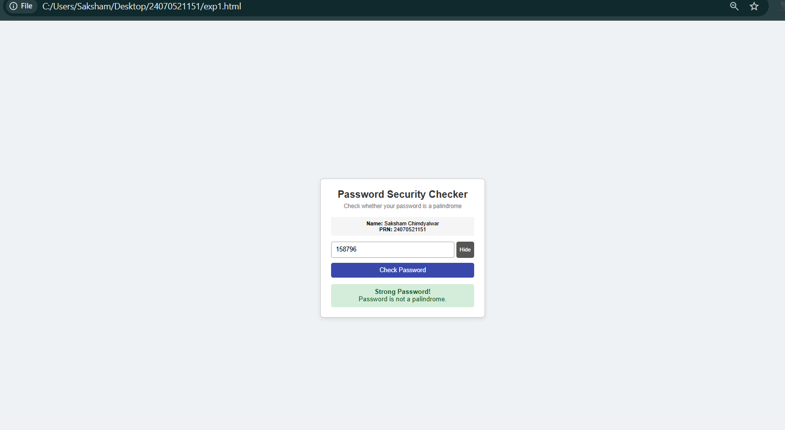



Experiment No. 5

Experiment Title: Array methods and objects handling; Create a cart total calculator with discount logic.
  - Software/Tools Required: VS Code, Html/JS Compiler…

Experiment Program Code:

const cart = [
{ name: "Book", price: 300, quantity: 2 },
{ name: "Pen", price: 20, quantity: 5 },
{ name: "Bag", price: 500, quantity: 1 },
];

const discountRules = [
{ minTotal: 2000, rate: 0.15, label: "15% off" },
{ minTotal: 1000, rate: 0.10, label: "10% off" },
{ minTotal: 500, rate: 0.05, label: "5% off" },
];

const calculateSubtotal = item => item.price * item.quantity;

const getDiscountRate = total => {
const rule = discountRules.find(rule => total >= rule.minTotal);
return rule ? rule.rate : 0;
};

const calculateCartTotal = cartItems => {
const cartWithSubtotal = cartItems.map(item => ({
...item,
subtotal: calculateSubtotal(item),
}));

const total = cartWithSubtotal.reduce((sum, item) => sum + item.subtotal, 0);
const discountRate = getDiscountRate(total);
const discount = total * discountRate;
const finalAmount = total - discount;

return {
cartWithSubtotal,
total,
discountRate,
discount,
finalAmount,
};
};

const printCartSummary = ({ cartWithSubtotal, total, discountRate, discount, finalAmount }) => {
console.log("Cart items:");
cartWithSubtotal.forEach(item => {
console.log(`- ${item.name}: ${item.quantity} × ${item.price} = ${item.subtotal}`);
});

console.log("Total Amount:", total);
console.log(`Discount (${discountRate * 100}%):`, discount);
console.log("Final Amount:", finalAmount);
};

const result = calculateCartTotal(cart);
printCartSummary(result);

Output:
- 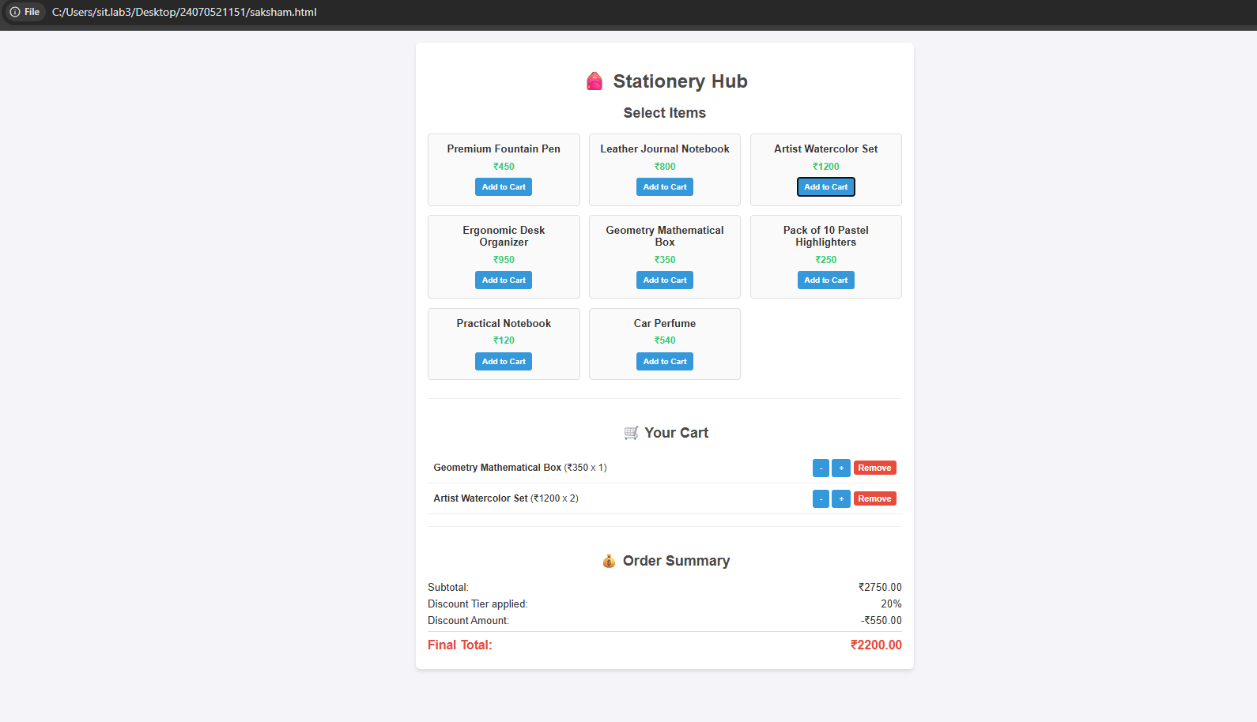

Case Study 5
- Case Study Title: To design and implement an interactive, client-side web application using HTML, CSS, and JavaScript for text analysis, string manipulation, and pattern matching (regex).

Case Study Program Code:
<!DOCTYPE html>
<html lang="en">
<head>
<meta charset="UTF-8">
<meta name="viewport" content="width=device-width, initial-scale=1.0">
<title>Saksham Chimdyalwar (24070521151)</title>
<style>
body {
font-family: Arial, sans-serif;
margin: 30px;
background-color: #f4f4f9;
color: #333;
}
.container {
background-color: #fff;
padding: 25px;
border-radius: 8px;
box-shadow: 0 4px 6px rgba(0,0,0,0.1);
max-width: 700px;
margin: 0 auto;
}
h1, h2 { color: #2c3e50; margin-top: 0; }
h2 { margin-top: 20px; font-size: 1.2rem; }
p { color: #555; margin-bottom: 15px; }

/* Input & Button Section */
.input-section { display: flex; gap: 8px; margin-bottom: 10px; flex-wrap: wrap; }
input {
padding: 10px; font-size: 16px;
border: 1px solid #ccc; border-radius: 4px; flex: 1; min-width: 120px;
}
button {
padding: 10px 14px; font-size: 14px;
color: white; border: none; border-radius: 4px;
cursor: pointer; transition: background 0.2s; white-space: nowrap;
}
.btn-add { background-color: #3498db; }
.btn-add:hover { background-color: #2980b9; }
.btn-manipulate { background-color: #8e44ad; }
.btn-manipulate:hover { background-color: #7d3c98; }
.btn-clear { background-color: #e74c3c; }
.btn-clear:hover { background-color: #c0392b; }

/* Output Boxes */
.output-box {
background-color: #272822; color: #f8f8f2;
padding: 15px; border-radius: 5px;
font-family: 'Courier New', Courier, monospace;
white-space: pre-wrap; line-height: 1.6;
margin-top: 8px; font-size: 14px; min-height: 40px;
}
.highlight-max { color: #a6e22e; font-weight: bold; }
.highlight-min { color: #f92672; font-weight: bold; }
.log-entry { color: #ae81ff; }
</style>
</head>
<body>

<div class="container">
<!-- ✅ Fixed typo: "dashbaord" → "Dashboard" -->
<h1>JS Array Study Dashboard</h1>
<p>Add numbers to build your array, then use manipulation buttons to see <code>push</code>, <code>pop</code>, <code>shift</code>, <code>unshift</code>, and <code>slice</code> in action.</p>

<!-- Input + All Manipulation Buttons -->
<div class="input-section">
<input type="number" id="num-input" placeholder="Type a number...">
<button class="btn-add" onclick="addNumber()">Push (Add)</button>
<button class="btn-manipulate" onclick="manipulate('pop')">Pop</button>
<button class="btn-manipulate" onclick="manipulate('shift')">Shift</button>
<button class="btn-manipulate" onclick="manipulate('unshift')">Unshift</button>
<button class="btn-manipulate" onclick="manipulate('slice')">Slice(1,3)</button>
<button class="btn-clear" onclick="clearArray()">Reset</button>
</div>

<h2>Current Array Status</h2>
<div id="array-display" class="output-box">Array is empty.</div>

<h2>Operation Log</h2>
<div id="operation-log" class="output-box">No operations yet.</div>

<h2>Case Study: Max &amp; Min (for loop)</h2>
<div id="case-study-output" class="output-box">Waiting for numbers...</div>

<h2>Array Iterator Methods</h2>
<div id="methods-output" class="output-box">Waiting for numbers...</div>
</div>

<script>
let userNumbers = [];
let logEntries = [];

// ─── ADD NUMBER (push) ──────────────────────────────
function addNumber() {
const inputField = document.getElementById("num-input");
const inputValue = inputField.value.trim();

if (inputValue === "") { alert("Please enter a valid number."); return; }

const num = Number(inputValue);
if (isNaN(num)) { alert("Invalid number."); return; }

userNumbers.push(num);
addLog(`push(${num}) → added to end`);
inputField.value = "";
inputField.focus();
updateDashboard();
}

// ─── MANIPULATE ARRAY ───────────────────────────────
function manipulate(operation) {
if (userNumbers.length === 0 && operation !== 'unshift') {
addLog(`⚠ ${operation}() called on empty array — no effect`);
updateDashboard();
return;
}

switch (operation) {
case 'pop': {
const removed = userNumbers.pop();
addLog(`pop() → removed "${removed}" from end`);
break;
}
case 'shift': {
const removed = userNumbers.shift();
addLog(`shift() → removed "${removed}" from start`);
break;
}
case 'unshift': {
const inputField = document.getElementById("num-input");
const val = Number(inputField.value.trim());
if (isNaN(val)) { alert("Enter a number first for unshift."); return; }
userNumbers.unshift(val);
addLog(`unshift(${val}) → added to start`);
inputField.value = "";
break;
}
case 'slice': {
const sliced = userNumbers.slice(1, 3);
addLog(`slice(1,3) → [${sliced.join(', ')}] (original unchanged)`);
break;
}
}
updateDashboard();
}

// ─── CLEAR ARRAY ────────────────────────────────────
function clearArray() {
userNumbers = [];
logEntries = [];
addLog("🔄 Array reset");
updateDashboard();
}

// ─── LOG HELPER ─────────────────────────────────────
function addLog(message) {
const timestamp = new Date().toLocaleTimeString();
logEntries.unshift(`[${timestamp}] ${message}`);
if (logEntries.length > 8) logEntries.pop(); // Keep last 8 entries
}

// ─── MASTER UPDATE FUNCTION ─────────────────────────
function updateDashboard() {
const arrayDisplay = document.getElementById("array-display");
const logDisplay = document.getElementById("operation-log");
const caseStudyOutput = document.getElementById("case-study-output");
const methodsOutput = document.getElementById("methods-output");

// Always show log
logDisplay.innerText = logEntries.length ? logEntries.join("\n") : "No operations yet.";

// Empty state
if (userNumbers.length === 0) {
arrayDisplay.innerText = "Array is empty.";
caseStudyOutput.innerText = "Waiting for numbers...";
methodsOutput.innerText = "Waiting for numbers...";
return;
}

// 1. Current Array
arrayDisplay.innerText = `[ ${userNumbers.join(", ")} ]`;

// 2. Case Study: Max & Min via for loop
let min = userNumbers[0], max = userNumbers[0];
for (let i = 1; i < userNumbers.length; i++) {
if (userNumbers[i] > max) max = userNumbers[i];
if (userNumbers[i] < min) min = userNumbers[i];
}
caseStudyOutput.innerHTML =
`<span class="highlight-max">Maximum: ${max}</span>\n<span class="highlight-min">Minimum: ${min}</span>`;

// 3. Iterator Methods
// forEach() — build a labeled index string
let forEachResult = [];
userNumbers.forEach((n, i) => forEachResult.push(`[${i}]:${n}`));

// map() — double each value
const doubled = userNumbers.map(n => n * 2);

// filter() — keep values > 10
const filtered = userNumbers.filter(n => n > 10);

// reduce() — sum all values
const sum = userNumbers.reduce((acc, cur) => acc + cur, 0);

methodsOutput.innerText =
`forEach() indices: ${forEachResult.join(" | ")}\n` +
`map() doubled: [ ${doubled.join(", ")} ]\n` +
`filter() (>10): [ ${filtered.join(", ")} ]\n` +
`reduce() sum: ${sum}`;
}

// Enter key support
document.getElementById("num-input").addEventListener("keypress", function(e) {
if (e.key === "Enter") addNumber();
});
</script>

</body>
</html>

Output:

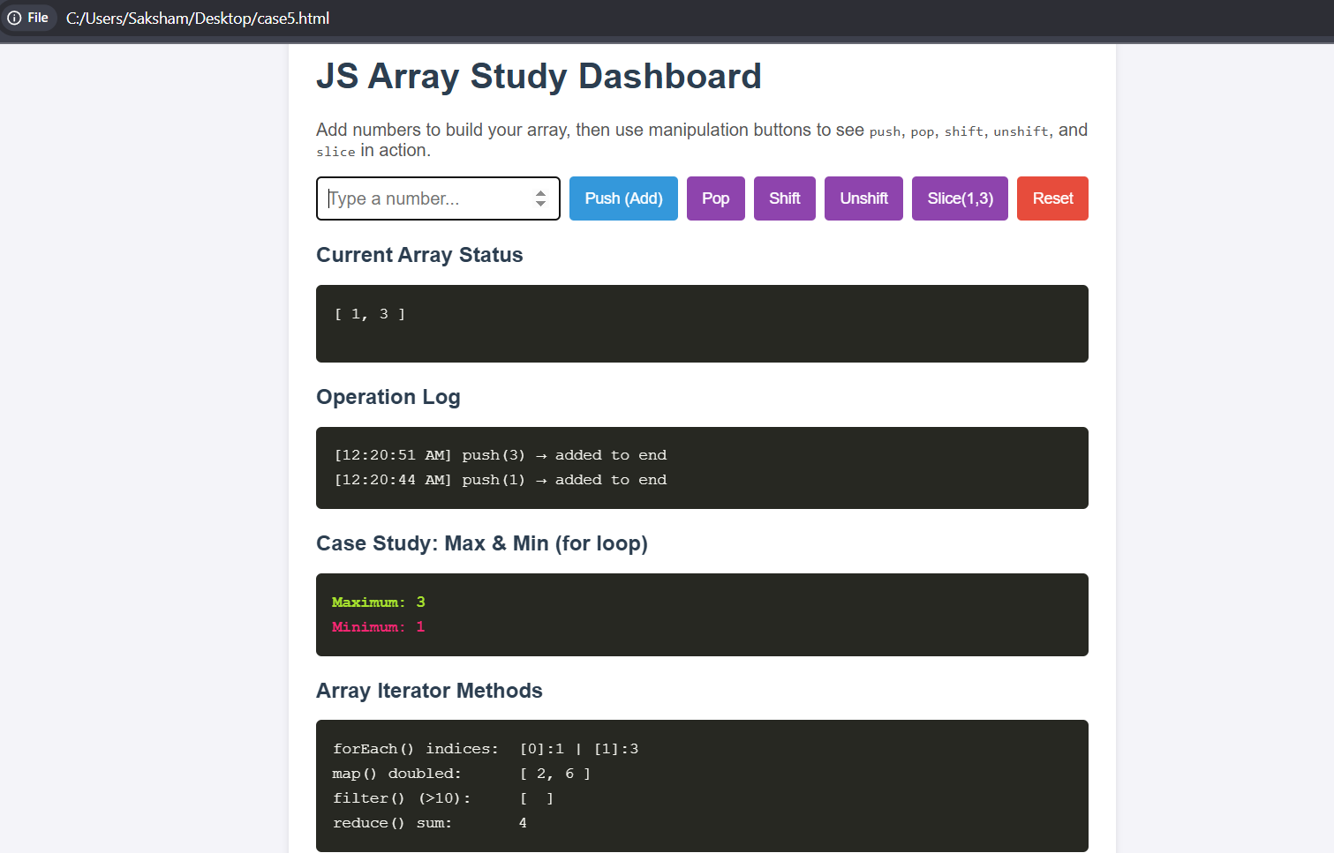

Experiment No. 6

Experiment Title: Use string functions and regex for email validation, data extraction, and text analysis.
- Software/Tools Required: VS Code, Html/JS Compiler…

Experiment Program Code:
<!DOCTYPE html>
<html lang="en">
<head>
<meta charset="UTF-8">
<meta name="viewport" content="width=device-width, initial-scale=1.0">
<title>Text Analyzer & Email Extractor</title>
<style>
body {
font-family: Arial, sans-serif;
background-color: #f4f7f6;
margin: 0;
padding: 20px;
}
.container {
max-width: 600px;
margin: auto;
background: #fff;
padding: 30px;
border-radius: 8px;
box-shadow: 0 4px 10px rgba(0,0,0,0.1);
}
h2 {
margin-top: 0;
color: #333;
}
textarea {
width: 100%;
height: 120px;
padding: 10px;
border: 1px solid #ccc;
border-radius: 4px;
resize: vertical;
box-sizing: border-box;
font-size: 14px;
}
button {
background-color: #007bff;
color: white;
padding: 10px 20px;
border: none;
border-radius: 4px;
cursor: pointer;
font-size: 16px;
margin-top: 10px;
}
button:hover {
background-color: #0056b3;
}
/* Style for the new Swap button */
.btn-swap {
background-color: #28a745;
margin-left: 5px;
}
.btn-swap:hover {
background-color: #218838;
}
.results {
margin-top: 20px;
background: #e9ecef;
padding: 15px;
border-radius: 4px;
}
.results p {
margin: 8px 0;
font-size: 15px;
}
.highlight {
font-weight: bold;
color: #007bff;
}
</style>
</head>
<body>
<div class="container">
<h2>Text Analyzer & Data Extraction</h2>
<p>Type or paste your paragraph below:</p>
<textarea id="userInput" placeholder="Type text containing emails and words here..."></textarea>
<br>
<button onclick="analyzeText()">Analyze Text</button>
<!-- Added Swap Case Button -->
<button onclick="swapCase()" class="btn-swap">Swap Case</button>

<div class="results" id="outputSection" style="display: none;">
<h3>Analysis Results</h3>
<p><strong>Text Length (Characters):</strong> <span id="charLength" class="highlight"></span></p>
<p><strong>Uppercase Count:</strong> <span id="upperCount" class="highlight"></span></p>
<p><strong>Lowercase Count:</strong> <span id="lowerCount" class="highlight"></span></p>
<p><strong>Contains "Welcome":</strong> <span id="welcomeFound" class="highlight"></span></p>
<p><strong>Extracted Valid Emails:</strong> <span id="emailList" class="highlight"></span></p>
</div>
</div>

<script>
function analyzeText() {
const text = document.getElementById('userInput').value;

// 1. Text Length
const charLength = text.length;

// 2. Uppercase and Lowercase counts
const upperCount = (text.match(/[A-Z]/g) || []).length;
const lowerCount = (text.match(/[a-z]/g) || []).length;

// 3. Contains "welcome" (case-insensitive)
const containsWelcome = /welcome/i.test(text);

// 4. Valid Email Extraction using Regex
const emailRegex = /[a-zA-Z0-9._%+-]+@[a-zA-Z0-9.-]+\.[a-zA-Z]{2,}/g;
const foundEmails = text.match(emailRegex) || [];

// Remove duplicates if any
const uniqueEmails = [...new Set(foundEmails)];

// Display results
document.getElementById('charLength').innerText = charLength;
document.getElementById('upperCount').innerText = upperCount;
document.getElementById('lowerCount').innerText = lowerCount;
document.getElementById('welcomeFound').innerText = containsWelcome ? "Yes" : "No";
document.getElementById('emailList').innerText = uniqueEmails.length > 0 ? uniqueEmails.join(', ') : "None found";
document.getElementById('outputSection').style.display = 'block';
}

// New feature: Swaps character casing and re-triggers analysis
function swapCase() {
const textArea = document.getElementById('userInput');
const text = textArea.value;

// Map over each letter to toggle case
const swappedText = text.replace(/./g, function(char) {
if (char === char.toUpperCase()) {
return char.toLowerCase();
} else {
return char.toUpperCase();
}
});

// Update the input field with swapped content
textArea.value = swappedText;

// Re-run analysis immediately to update counts
analyzeText();
}
</script>
</body>
</html>

4.Output:
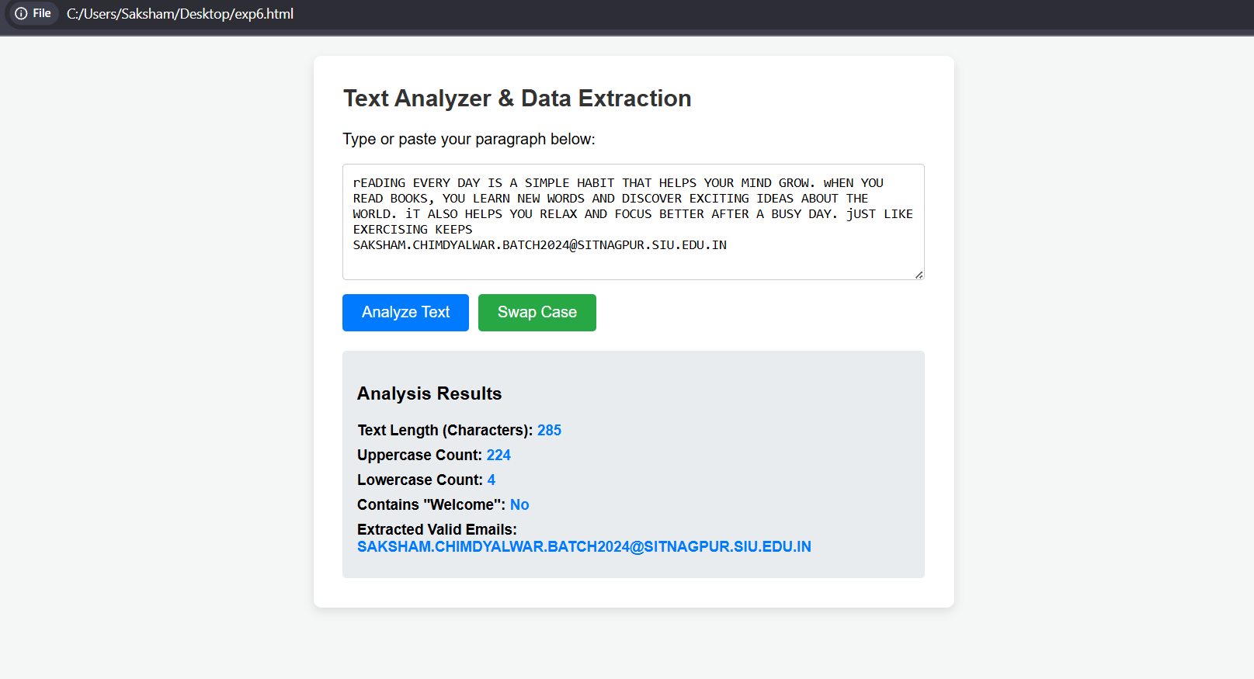
Case Study 6
- Case Study Title: To design and implement a web application using HTML, CSS, and JavaScript to perform specific string manipulation operations (reversing a string and counting vowels) on user-provided input.

Case Study Program Code:
<!DOCTYPE html>
<html lang="en">
<head>
<meta charset="UTF-8">
<meta name="viewport" content="width=device-width, initial-scale=1.0">
<title>Saksham Chimdyalwar 24070521151</title>
<style>
* {
margin: 0;
padding: 0;
box-sizing: border-box;
}

body {
font-family: 'Segoe UI', Tahoma, Geneva, Verdana, sans-serif;
background: linear-gradient(135deg, #667eea 0%, #764ba2 100%);
min-height: 100vh;
padding: 20px;
}

.container {
max-width: 900px;
margin: 0 auto;
background: white;
border-radius: 15px;
box-shadow: 0 10px 30px rgba(0,0,0,0.3);
padding: 30px;
}

h1 {
text-align: center;
color: #667eea;
margin-bottom: 30px;
font-size: 2em;
border-bottom: 3px solid #667eea;
padding-bottom: 10px;
}

.section {
margin-bottom: 30px;
padding: 20px;
background: #f8f9fa;
border-radius: 10px;
border-left: 5px solid #667eea;
}

.section h2 {
color: #764ba2;
margin-bottom: 15px;
font-size: 1.5em;
}

label {
display: block;
margin-bottom: 8px;
color: #333;
font-weight: 600;
}

input[type="text"], textarea {
width: 100%;
padding: 12px;
border: 2px solid #ddd;
border-radius: 8px;
font-size: 16px;
margin-bottom: 15px;
transition: border-color 0.3s;
}

input[type="text"]:focus, textarea:focus {
outline: none;
border-color: #667eea;
}

textarea {
resize: vertical;
min-height: 100px;
}

button {
background: linear-gradient(135deg, #667eea 0%, #764ba2 100%);
color: white;
border: none;
padding: 12px 25px;
border-radius: 8px;
cursor: pointer;
font-size: 16px;
font-weight: 600;
margin-right: 10px;
margin-bottom: 10px;
transition: transform 0.2s, box-shadow 0.2s;
}

button:hover {
transform: translateY(-2px);
box-shadow: 0 5px 15px rgba(102, 126, 234, 0.4);
}

button:active {
transform: translateY(0);
}

.result {
margin-top: 15px;
padding: 15px;
background: #e7f3ff;
border-radius: 8px;
border-left: 4px solid #667eea;
display: none;
}

.result.show {
display: block;
animation: fadeIn 0.5s;
}

.result strong {
color: #764ba2;
}

.string-operations {
display: grid;
grid-template-columns: 1fr 1fr;
gap: 15px;
margin-top: 15px;
}

.operation-box {
background: white;
padding: 15px;
border-radius: 8px;
border: 2px solid #ddd;
}

.operation-box h3 {
color: #667eea;
margin-bottom: 10px;
font-size: 1.1em;
}

@keyframes fadeIn {
from { opacity: 0; transform: translateY(-10px); }
to { opacity: 1; transform: translateY(0); }
}

.stats {
display: flex;
gap: 20px;
flex-wrap: wrap;
margin-top: 15px;
}

.stat-item {
background: white;
padding: 15px 25px;
border-radius: 8px;
border: 2px solid #667eea;
text-align: center;
}

.stat-item .number {
font-size: 2em;
font-weight: bold;
color: #764ba2;
}

.stat-item .label {
color: #666;
font-size: 0.9em;
}
</style>
</head>
<body>
<div class="container">
<h1>Saksham Chimdyalwar 24070521151 </h1>

<!-- Case Study 1: Reverse String -->
<div class="section">
<h2>1. Reverse a String</h2>
<label for="inputString">Enter a string:</label>
<input type="text" id="inputString" placeholder="Type something to reverse...">
<button onclick="reverseString()">Reverse String</button>
<button onclick="clearReverse()">Clear</button>
<div id="reverseResult" class="result">
<strong>Reversed String:</strong> <span id="reversedText"></span>
</div>
</div>

<!-- Case Study 2: Count Vowels -->
<div class="section">
<h2>2. Count Vowels in a Paragraph</h2>
<label for="paragraph">Enter a paragraph:</label>
<textarea id="paragraph" placeholder="Type or paste your paragraph here..."></textarea>
<button onclick="countVowels()">Count Vowels</button>
<button onclick="clearVowels()">Clear</button>
<div id="vowelResult" class="result">
<div class="stats">
<div class="stat-item">
<div class="number" id="totalVowels">0</div>
<div class="label">Total Vowels</div>
</div>
<div class="stat-item">
<div class="number" id="totalConsonants">0</div>
<div class="label">Consonants</div>
</div>
<div class="stat-item">
<div class="number" id="totalChars">0</div>
<div class="label">Total Characters</div>
</div>
</div>
<div style="margin-top: 15px;">
<strong>Vowel Details:</strong><br>
<span id="vowelDetails"></span>
</div>
</div>
</div>

<!-- String Operations Demo -->
<div class="section">
<h2>3. String Operations Demo (substring, indexOf, split, replace)</h2>
<label for="demoString">Enter a string for operations:</label>
<input type="text" id="demoString" placeholder="Enter text to demonstrate operations...">
<button onclick="performOperations()">Perform Operations</button>
<div id="operationsResult" class="result">
<div class="string-operations">
<div class="operation-box">
<h3>substring(0, 5)</h3>
<p id="substringResult">-</p>
</div>
<div class="operation-box">
<h3>indexOf()</h3>
<p id="indexOfResult">-</p>
</div>
<div class="operation-box">
<h3>split()</h3>
<p id="splitResult">-</p>
</div>
<div class="operation-box">
<h3>replace()</h3>
<p id="replaceResult">-</p>
</div>
</div>
</div>
</div>
</div>

<script>
// Case Study 1: Reverse String
function reverseString() {
const input = document.getElementById('inputString').value;
if (input.trim() === '') {
alert('Please enter a string first!');
return;
}
const reversed = input.split('').reverse().join('');
document.getElementById('reversedText').textContent = reversed;
document.getElementById('reverseResult').classList.add('show');
}

function clearReverse() {
document.getElementById('inputString').value = '';
document.getElementById('reverseResult').classList.remove('show');
}

// Case Study 2: Count Vowels
function countVowels() {
const text = document.getElementById('paragraph').value;
if (text.trim() === '') {
alert('Please enter a paragraph first!');
return;
}

const vowels = text.match(/[aeiouAEIOU]/g) || [];
const consonants = text.match(/[bcdfghjklmnpqrstvwxyzBCDFGHJKLMNPQRSTVWXYZ]/g) || [];
const totalChars = text.replace(/\s/g, '').length;

document.getElementById('totalVowels').textContent = vowels.length;
document.getElementById('totalConsonants').textContent = consonants.length;
document.getElementById('totalChars').textContent = totalChars;

// Count individual vowels
const vowelCount = {
'a': 0, 'e': 0, 'i': 0, 'o': 0, 'u': 0
};

text.toLowerCase().split('').forEach(char => {
if (vowelCount.hasOwnProperty(char)) {
vowelCount[char]++;
}
});

let details = '<ul style="margin-top: 10px; padding-left: 20px;">';
for (let vowel in vowelCount) {
details += `<li><strong>${vowel.toUpperCase()}:</strong> ${vowelCount[vowel]} times</li>`;
}
details += '</ul>';
document.getElementById('vowelDetails').innerHTML = details;

document.getElementById('vowelResult').classList.add('show');
}

function clearVowels() {
document.getElementById('paragraph').value = '';
document.getElementById('vowelResult').classList.remove('show');
}

// String Operations Demo
function performOperations() {
const str = document.getElementById('demoString').value;
if (str.trim() === '') {
alert('Please enter a string first!');
return;
}

// substring
document.getElementById('substringResult').textContent = str.substring(0, 5);

// indexOf (find first space)
const spaceIndex = str.indexOf(' ');
document.getElementById('indexOfResult').textContent = spaceIndex !== -1
? `First space at position: ${spaceIndex}`
: 'No space found';

// split
const words = str.split(' ');
document.getElementById('splitResult').textContent = `Words: ${words.length}\n[${words.join(', ')}]`;

// replace
const replaced = str.replace(/\s/g, '-');
document.getElementById('replaceResult').textContent = `Spaces to -: ${replaced}`;

document.getElementById('operationsResult').classList.add('show');
}
</script>
</body>
</html>

Output:

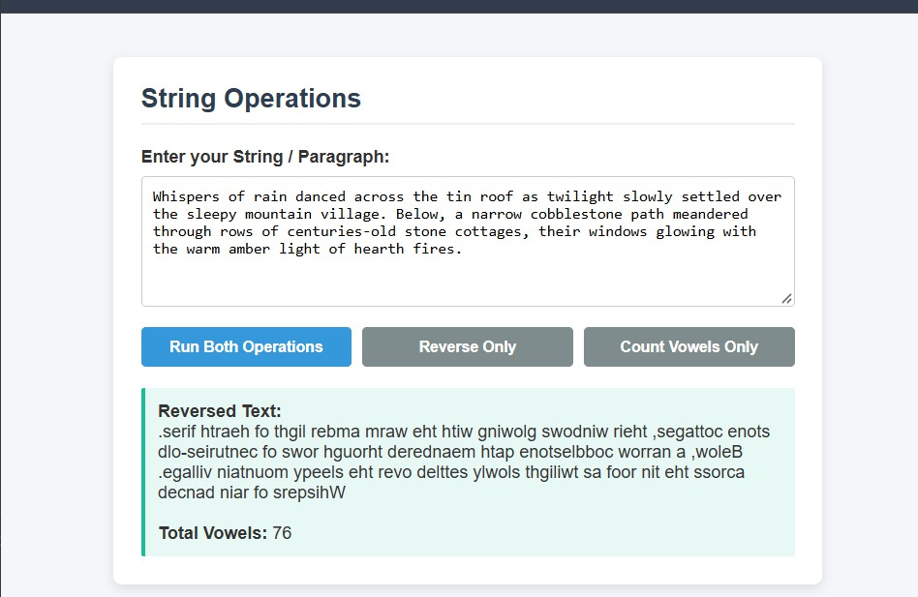

Experiment No. 7

Experiment Title: Perform DOM Traversal and update; develop a to-do list app with add, edit, and delete features.
  - Software/Tools Required: VS Code, Html/JS Compiler…

Experiment Program Code:
<!DOCTYPE html>
<html lang="en">
<head>
<meta charset="UTF-8">
<meta name="viewport" content="width=device-width, initial-scale=1.0">
<title>To-Do List with Stats counter</title>
<style>
:root {
--bg-color: #f4f7f6;
--card-bg: #ffffff;
--text-color: #333333;
--primary-color: #4a90e2;
--edit-color: #f39c12;
--delete-color: #e74c3c;
--border-color: #e0e0e0;
--done-color: #2ecc71;
}

body {
font-family: 'Segoe UI', Tahoma, Geneva, Verdana, sans-serif;
background-color: var(--bg-color);
color: var(--text-color);
display: flex;
justify-content: center;
align-items: center;
min-height: 100vh;
margin: 0;
}

.todo-container {
background-color: var(--card-bg);
padding: 30px;
border-radius: 12px;
box-shadow: 0 8px 24px rgba(0, 0, 0, 0.05);
width: 100%;
max-width: 480px;
}

h2 {
margin-top: 0;
text-align: center;
color: #2c3e50;
}

.input-group {
display: flex;
gap: 10px;
margin-bottom: 20px;
}

input[type="text"] {
flex: 1;
padding: 12px;
border: 2px solid var(--border-color);
border-radius: 6px;
font-size: 16px;
outline: none;
transition: border-color 0.3s;
}

input[type="text"]:focus {
border-color: var(--primary-color);
}

button {
padding: 12px 20px;
border: none;
border-radius: 6px;
cursor: pointer;
font-weight: 600;
font-size: 14px;
transition: background-color 0.2s;
}

#add-btn {
background-color: var(--primary-color);
color: white;
}

#add-btn:hover {
background-color: #357abd;
}

ul {
list-style: none;
padding: 0;
margin: 0;
max-height: 350px;
overflow-y: auto;
}

li {
display: flex;
align-items: center;
justify-content: space-between;
padding: 12px;
background: #fafafa;
border: 1px solid var(--border-color);
border-radius: 6px;
margin-bottom: 10px;
gap: 12px;
transition: opacity 0.2s, background-color 0.2s;
}

li.completed-row {
background-color: #f0fbf5;
border-color: #c2eed5;
}

.task-left-section {
display: flex;
align-items: center;
gap: 12px;
flex: 1;
}

.done-checkbox {
width: 20px;
height: 20px;
cursor: pointer;
accent-color: var(--done-color);
}

.task-text {
flex: 1;
word-break: break-word;
font-size: 16px;
transition: color 0.2s;
}

.task-text.completed {
text-decoration: line-through;
color: #7f8c8d;
}

.edit-input {
flex: 1;
padding: 8px;
font-size: 16px;
border: 1px solid var(--edit-color);
border-radius: 4px;
}

.action-btns {
display: flex;
gap: 5px;
}

.edit-btn {
background-color: var(--edit-color);
color: white;
}

.edit-btn:hover {
background-color: #d35400;
}

.delete-btn {
background-color: var(--delete-color);
color: white;
}

.delete-btn:hover {
background-color: #c0392b;
}

/* NEW: Stats Summary Counter Styling */
.todo-summary {
display: flex;
justify-content: space-between;
align-items: center;
margin-top: 20px;
padding-top: 15px;
border-top: 2px solid var(--bg-color);
font-size: 14px;
color: #555555;
font-weight: 500;
}

.stat-item span {
font-weight: 700;
color: #2c3e50;
}

.stat-item.done-count span {
color: var(--done-color);
}
</style>
</head>
<body>

<div class="todo-container">
<h2>24070521151</h2>

<div class="input-group">
<input type="text" id="todo-input" placeholder="Add a new task..." autocomplete="off">
<button id="add-btn">Add Task</button>
</div>

<ul id="todo-list"></ul>

<!-- NEW: Total tasks dashboard counter option section -->
<div class="todo-summary">
<div class="stat-item">Total Tasks: <span id="total-count">0</span></div>
<div class="stat-item">Pending: <span id="pending-count">0</span></div>
<div class="stat-item done-count">Completed: <span id="completed-count">0</span></div>
</div>
</div>

<script>
const todoInput = document.getElementById('todo-input');
const addBtn = document.getElementById('add-btn');
const todoList = document.getElementById('todo-list');

// Counter Elements
const totalCountEl = document.getElementById('total-count');
const pendingCountEl = document.getElementById('pending-count');
const completedCountEl = document.getElementById('completed-count');

let tasks = JSON.parse(localStorage.getItem('tasks')) || [];

function saveTasks() {
localStorage.setItem('tasks', JSON.stringify(tasks));
}

// NEW: Updates counts at the bottom bar layout element
function updateSummaryCounters() {
const total = tasks.length;
const completed = tasks.filter(task => task.completed).length;
const pending = total - completed;

totalCountEl.textContent = total;
pendingCountEl.textContent = pending;
completedCountEl.textContent = completed;
}

function renderTasks() {
todoList.innerHTML = '';

tasks.forEach((task, index) => {
const li = document.createElement('li');

if (task.completed) {
li.classList.add('completed-row');
}

if (task.isEditing) {
li.innerHTML = `
<input type="text" class="edit-input" value="${task.text}" id="edit-input-${index}">
<div class="action-btns">
<button class="edit-btn" onclick="saveEdit(${index})">Save</button>
<button class="delete-btn" onclick="toggleEdit(${index})">Cancel</button>
</div>
`;
} else {
li.innerHTML = `
<div class="task-left-section">
<input
type="checkbox"
class="done-checkbox"
${task.completed ? 'checked' : ''}
onclick="toggleComplete(${index})"
title="Mark as Done"
>
<span class="task-text ${task.completed ? 'completed' : ''}">
${task.text}
</span>
</div>
<div class="action-btns">
<button class="edit-btn" onclick="toggleEdit(${index})">Modify</button>
<button class="delete-btn" onclick="deleteTask(${index})">Delete</button>
</div>
`;
}

todoList.appendChild(li);
});

// Re-calculate statistics layout figures every render cycle
updateSummaryCounters();
}

function addTask() {
const taskText = todoInput.value.trim();
if (taskText === '') return;

tasks.push({
text: taskText,
completed: false,
isEditing: false
});

todoInput.value = '';
saveTasks();
renderTasks();
}

function deleteTask(index) {
tasks.splice(index, 1);
saveTasks();
renderTasks();
}

function toggleEdit(index) {
tasks[index].isEditing = !tasks[index].isEditing;
renderTasks();
}

function saveEdit(index) {
const editInput = document.getElementById(`edit-input-${index}`);
const updatedText = editInput.value.trim();

if (updatedText !== '') {
tasks[index].text = updatedText;
tasks[index].isEditing = false;
saveTasks();
renderTasks();
}
}

function toggleComplete(index) {
tasks[index].completed = !tasks[index].completed;
saveTasks();
renderTasks();
}

addBtn.addEventListener('click', addTask);
todoInput.addEventListener('keypress', (e) => {
if (e.key === 'Enter') addTask();
});

renderTasks();
</script>

</body>
</html>

Output:
- 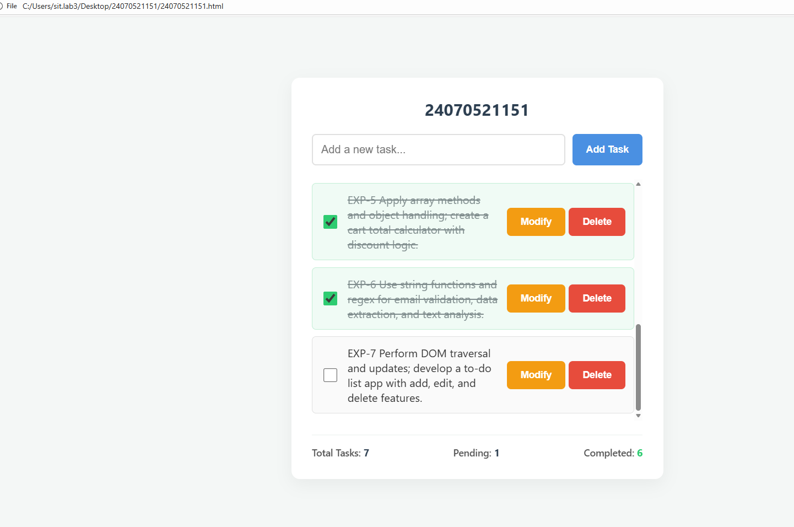

Case Study 7
- Case Study Title: To design, style, and implement an interactive Student Registration Form using HTML5, CSS3, and JavaScript, featuring responsive card-based layout structuring, dynamic focus/blur UI micro-interactions, and comprehensive client-side form validation.

Case Study Program Code:
<!DOCTYPE html>
<html lang="en">
<head>
<meta charset="UTF-8">
<meta name="viewport" content="width=device-width, initial-scale=1.0">
<title>Centered JavaScript Event Handling Form</title>
<style>
/* Centers the form box perfectly on the screen */
html, body {
height: 100%;
margin: 0;
padding: 0;
}
body {
font-family: Arial, sans-serif;
background-color: #f4f4f9;
display: flex;
justify-content: center;
align-items: center;
}
form {
background: white;
padding: 30px;
border-radius: 8px;
width: 100%;
max-width: 420px;
box-shadow: 0 4px 15px rgba(0,0,0,0.1);
box-sizing: border-box;
}
h2 {
margin-top: 0;
margin-bottom: 20px;
text-align: center;
color: #333;
}
div {
margin-bottom: 15px;
}
label {
display: block;
margin-bottom: 5px;
font-weight: bold;
font-size: 0.9em;
}
input, select {
width: 100%;
padding: 10px;
border: 1px solid #ccc;
border-radius: 4px;
box-sizing: border-box;
}
/* Checkbox wrapper layout styling */
.checkbox-group {
display: flex;
align-items: center;
gap: 8px;
}
.checkbox-group input {
width: auto;
}
.checkbox-group label {
display: inline;
margin: 0;
}
input:focus, select:focus {
border-color: #0056b3;
background-color: #f0f7ff;
outline: none;
}
.error {
color: red;
font-size: 0.8em;
margin-top: 5px;
display: none;
}
button {
background-color: #0056b3;
color: white;
padding: 12px 15px;
border: none;
border-radius: 4px;
cursor: pointer;
width: 100%;
font-size: 1em;
margin-top: 10px;
}
button:hover {
background-color: #004085;
}
#log-panel {
margin-top: 15px;
font-size: 0.85em;
color: #555;
font-style: italic;
text-align: center;
min-height: 20px;
}
</style>
</head>
<body>

<form id="registrationForm">
<h2>Registration Form</h2>

<!-- Field 1: Full Name (focus event) -->
<div>
<label for="username">Full Name:</label>
<input type="text" id="username" placeholder="Enter your full name">
<small id="nameError" class="error">Name field cannot be empty.</small>
</div>

<!-- Field 2: Email Address (validation) -->
<div>
<label for="email">Email Address:</label>
<input type="text" id="email" placeholder="example@domain.com">
<small id="emailError" class="error">Please enter a valid email address.</small>
</div>

<!-- NEW Field 3: Phone Number (validation) -->
<div>
<label for="phone">Phone Number:</label>
<input type="text" id="phone" placeholder="Enter 10-digit number">
<small id="phoneError" class="error">Please enter a valid 10-digit phone number.</small>
</div>

<!-- Field 4: Contact Preference (change event) -->
<div>
<label for="preference">Contact Preference:</label>
<select id="preference">
<option value="Email">Email</option>
<option value="Phone">Phone</option>
</select>
</div>

<!-- NEW Field 5: Terms Checkbox (validation) -->
<div class="checkbox-group">
<input type="checkbox" id="terms">
<label for="terms">I agree to the terms and conditions</label>
</div>
<small id="termsError" class="error">You must accept the terms to proceed.</small>

<button type="submit">Submit Form</button>

<p id="log-panel"></p>
</form>

<script>
// DOM element selections
const form = document.getElementById('registrationForm');
const username = document.getElementById('username');
const email = document.getElementById('email');
const phone = document.getElementById('phone');
const preference = document.getElementById('preference');
const terms = document.getElementById('terms');
const logPanel = document.getElementById('log-panel');

// Error message elements
const nameError = document.getElementById('nameError');
const emailError = document.getElementById('emailError');
const phoneError = document.getElementById('phoneError');
const termsError = document.getElementById('termsError');

// Logger utility
function logEvent(message) {
logPanel.innerText = `Event Tracker: ${message}`;
}

// Focus events
username.addEventListener('focus', () => logEvent("Focused on 'Full Name'."));
email.addEventListener('focus', () => logEvent("Focused on 'Email'."));
phone.addEventListener('focus', () => logEvent("Focused on 'Phone'."));

// Change event
preference.addEventListener('change', (e) => {
logEvent(`Contact preference shifted to: ${e.target.value}`);
});

// Submit and Validation events
form.addEventListener('submit', (event) => {
event.preventDefault();
logEvent("Form submission initiated.");

let isValid = true;

// 1. Validate Name
if (username.value.trim() === "") {
nameError.style.display = "block";
isValid = false;
} else {
nameError.style.display = "none";
}

// 2. Validate Email
const emailRegex = /^[^\s@]+@[^\s@]+\.[^\s@]+$/;
if (!emailRegex.test(email.value.trim())) {
emailError.style.display = "block";
isValid = false;
} else {
emailError.style.display = "none";
}

// 3. Validate Phone (Matches simple 10 digit pattern)
const phoneRegex = /^\d{10}$/;
if (!phoneRegex.test(phone.value.trim())) {
phoneError.style.display = "block";
isValid = false;
} else {
phoneError.style.display = "none";
}

// 4. Validate Checkbox
if (!terms.checked) {
termsError.style.display = "block";
isValid = false;
} else {
termsError.style.display = "none";
}

// Final check handler
if (isValid) {
alert("Success! Form data verified and processed.");
form.reset();
logPanel.innerText = "";
}
});
</script>

</body>
</html>

Output:
- 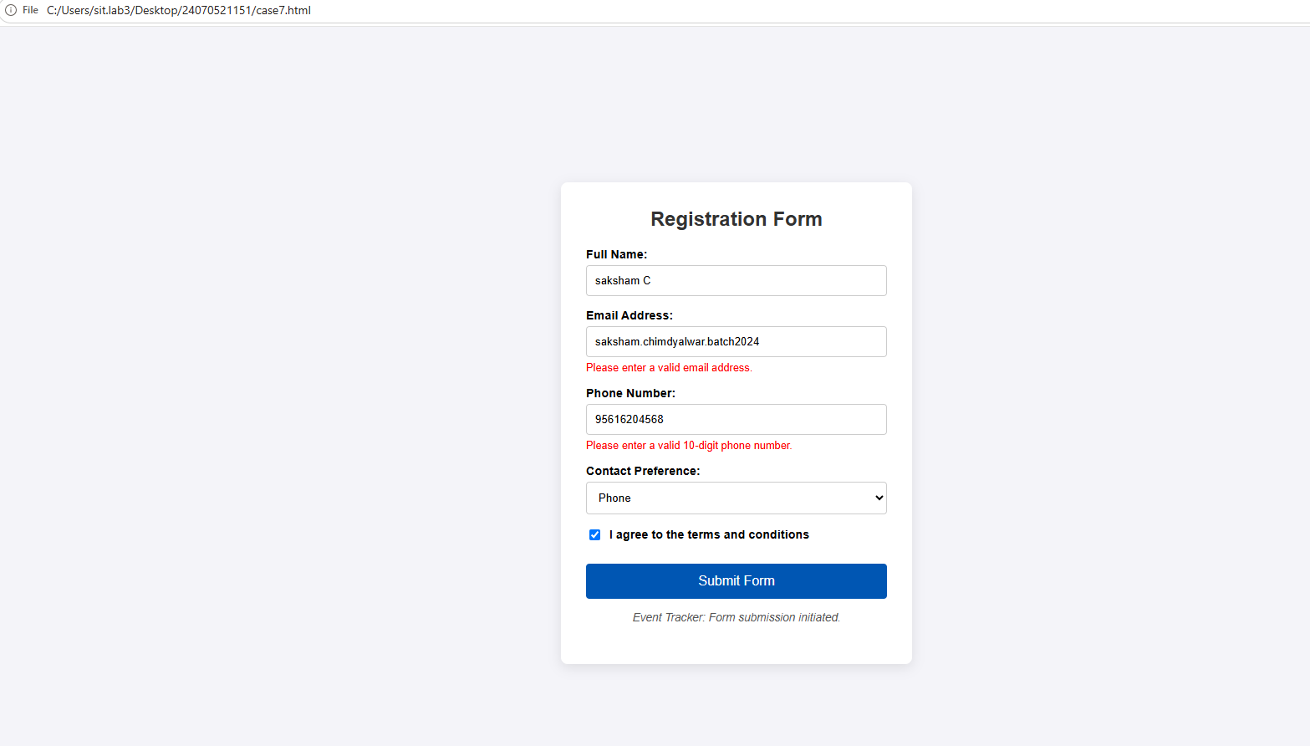

Experiment No. 8

Experiment Title: Access and validate form fields using events; design a gym registration form with live input checks.
- Software/Tools Required: VS Code, Html/JS Compiler…

Experiment Program Code:
<!DOCTYPE html>
<html lang="en">
<head>
<meta charset="UTF-8">
<meta name="viewport" content="width=device-width, initial-scale=1.0">
<title>Gym Admission Form</title>
<style>
:root {
--primary-color: #ff4757;
--secondary-color: #2f3542;
--bg-color: #f1f2f6;
--card-bg: #ffffff;
--error-color: #ff4757;
--success-color: #2ed573;
}
body {
font-family: 'Segoe UI', Tahoma, Geneva, Verdana, sans-serif;
background-color: var(--bg-color);
color: var(--secondary-color);
margin: 0;
padding: 20px;
display: flex;
justify-content: center;
align-items: center;
min-height: 100vh;
}
.form-container {
background-color: var(--card-bg);
padding: 30px;
border-radius: 12px;
box-shadow: 0 8px 24px rgba(0, 0, 0, 0.1);
width: 100%;
max-width: 500px;
}
h2 {
text-align: center;
margin-bottom: 24px;
color: var(--secondary-color);
text-transform: uppercase;
letter-spacing: 1px;
}
.form-group {
margin-bottom: 20px;
position: relative;
}
label {
display: block;
margin-bottom: 8px;
font-weight: 600;
font-size: 14px;
}
input[type="text"], input[type="email"], input[type="tel"], input[type="number"], select {
width: 100%;
padding: 12px;
border: 2px solid #ccc;
border-radius: 6px;
font-size: 16px;
box-sizing: border-box;
transition: border-color 0.3s ease;
background-color: #fff;
}
input:focus, select:focus {
outline: none;
border-color: var(--secondary-color);
}
.input-error {
border-color: var(--error-color) !important;
}
.error-message {
color: var(--error-color);
font-size: 12px;
margin-top: 5px;
display: none;
font-weight: 500;
}
/* Price Summary Card Styles */
.price-summary {
background-color: #f8f9fa;
border-left: 4px solid var(--primary-color);
padding: 15px;
border-radius: 6px;
margin-bottom: 20px;
display: none;
animation: fadeIn 0.3s ease;
}
.price-summary p {
margin: 5px 0;
font-size: 15px;
}
.price-amount {
font-size: 20px;
font-weight: bold;
color: var(--secondary-color);
}
button {
width: 100%;
background-color: var(--primary-color);
color: white;
border: none;
padding: 14px;
border-radius: 6px;
font-size: 16px;
font-weight: bold;
cursor: pointer;
margin-top: 10px;
transition: background-color 0.3s ease;
}
button:hover {
background-color: #ff6b81;
}
@keyframes fadeIn {
from { opacity: 0; transform: translateY(-5px); }
to { opacity: 1; transform: translateY(0); }
}
</style>
</head>
<body>
<div class="form-container">
<h2>Gym Admission</h2>
<form id="gymForm" onsubmit="return validateForm(event)">
<!-- Name Field -->
<div class="form-group">
<label for="fullName">Full Name</label>
<input type="text" id="fullName" placeholder="John Doe" required>
</div>

<!-- Email Field -->
<div class="form-group">
<label for="email">Email Address</label>
<input type="email" id="email" placeholder="name@example.com" required>
<div id="emailError" class="error-message">Please enter a valid email address.</div>
</div>

<!-- Mobile Number Field -->
<div class="form-group">
<label for="mobile">Mobile Number</label>
<input type="tel" id="mobile" placeholder="Enter 10-digit number" required>
<div id="mobileError" class="error-message">Please enter exactly 10 digits.</div>
</div>

<!-- Age Field -->
<div class="form-group">
<label for="age">Age</label>
<input type="number" id="age" placeholder="Enter your age" required>
</div>

<!-- Membership Plan (Prices updated to INR ₹) -->
<div class="form-group">
<label for="membership">Membership Plan</label>
<select id="membership" required>
<option value="" disabled selected>Select a plan...</option>
<option value="Monthly" data-price="₹1,500" data-billing="Billed monthly">Monthly Plan (₹1,500 / mo)</option>
<option value="Quarterly" data-price="₹4,000" data-billing="Billed every 3 months (Save 11%)">Quarterly Plan (₹4,000 / 3 mos)</option>
<option value="Yearly" data-price="₹12,000" data-billing="Billed annually (Save 33%)">Yearly Plan (₹12,000 / yr)</option>
</select>
</div>

<!-- Dynamic Price Summary Block -->
<div id="priceSummary" class="price-summary">
<p>Selected Plan: <strong id="summaryPlanName">-</strong></p>
<p>Billing Details: <span id="summaryBilling">-</span></p>
<p>Total Due: <span id="summaryPrice" class="price-amount">-</span></p>
</div>

<button type="submit">Join Gym</button>
</form>
</div>

<script>
const mobileInput = document.getElementById('mobile');
const mobileError = document.getElementById('mobileError');
const emailInput = document.getElementById('email');
const emailError = document.getElementById('emailError');

const membershipSelect = document.getElementById('membership');
const priceSummary = document.getElementById('priceSummary');
const summaryPlanName = document.getElementById('summaryPlanName');
const summaryBilling = document.getElementById('summaryBilling');
const summaryPrice = document.getElementById('summaryPrice');

// Live Mobile Validation
mobileInput.addEventListener('input', () => {
mobileInput.value = mobileInput.value.replace(/\D/g, '');
if (mobileInput.value.length !== 10 && mobileInput.value.length > 0) {
mobileError.textContent = `Please enter exactly 10 digits (Current: ${mobileInput.value.length})`;
mobileError.style.display = 'block';
mobileInput.classList.add('input-error');
} else {
mobileError.style.display = 'none';
mobileInput.classList.remove('input-error');
}
});

// Live Email Validation
emailInput.addEventListener('input', () => {
const emailPattern = /^[^\s@]+@[^\s@]+\.[^\s@]+$/;
if (!emailPattern.test(emailInput.value) && emailInput.value.length > 0) {
emailError.style.display = 'block';
emailInput.classList.add('input-error');
} else {
emailError.style.display = 'none';
emailInput.classList.remove('input-error');
}
});

// Dynamic Pricing Display Logic
membershipSelect.addEventListener('change', () => {
const selectedOption = membershipSelect.options[membershipSelect.selectedIndex];

if (selectedOption.value) {
summaryPlanName.textContent = selectedOption.value + " Plan";
summaryBilling.textContent = selectedOption.getAttribute('data-billing');
summaryPrice.textContent = selectedOption.getAttribute('data-price');
priceSummary.style.display = 'block';
} else {
priceSummary.style.display = 'none';
}
});

// Form Submission Safeguard
function validateForm(event) {
event.preventDefault();
if (mobileInput.value.length !== 10) {
alert('Please enter a valid 10-digit mobile number.');
return false;
}

const selectedPlan = membershipSelect.value;
const selectedPrice = membershipSelect.options[membershipSelect.selectedIndex].getAttribute('data-price');

alert(`Form submitted successfully!\nWelcome to the gym.\nYou selected the ${selectedPlan} Plan (${selectedPrice}).`);

document.getElementById('gymForm').reset();
priceSummary.style.display = 'none';
return true;
}
</script>
</body>
</html>

Output:

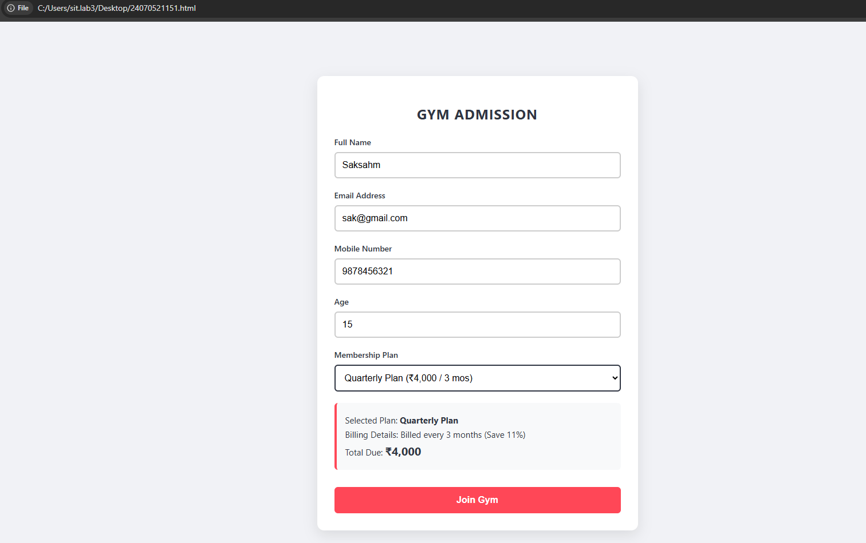

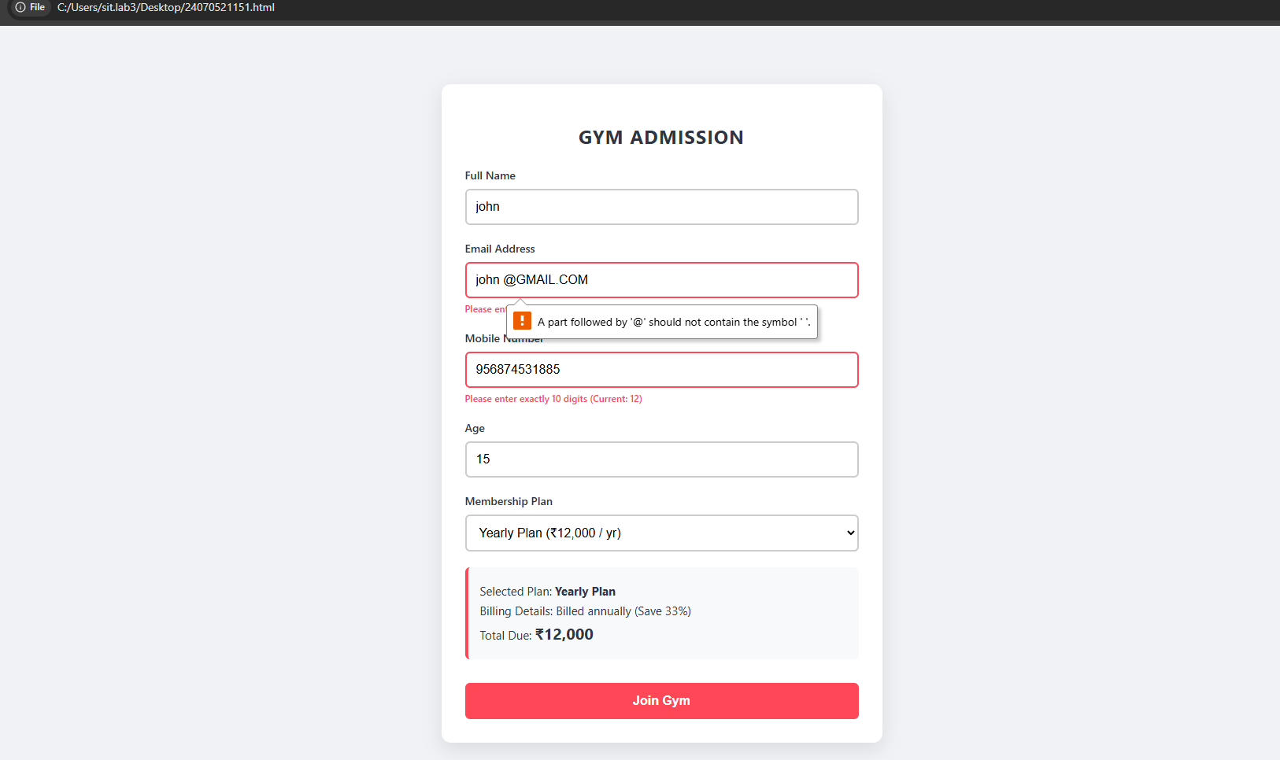

Case Study 8
- Case Study Title: To design and implement a responsive, multi-section Job Application Form styled with modern CSS gradients and card layout.

Case Study Program Code:
<!DOCTYPE html>
<html lang="en">
<head>
<meta charset="UTF-8">
<meta name="viewport" content="width=device-width, initial-scale=1.0">

<title>Job Application</title>

<style>
* {
margin: 0;
padding: 0;
box-sizing: border-box;
font-family: "Segoe UI", Arial, sans-serif;
}

body {
min-height: 100vh;
background: linear-gradient(135deg, #141e30, #243b55);
padding: 35px 15px;
color: #222;
}

/* MAIN CARD */

.container {
max-width: 1050px;
margin: auto;
background: #ffffff;
border-radius: 22px;
overflow: hidden;
box-shadow: 0 20px 60px rgba(0,0,0,0.25);
}

/* HEADER */

.header {
background: linear-gradient(135deg, #6a11cb, #2575fc);
color: white;
padding: 45px 40px;
position: relative;
}

.header h1 {
font-size: 34px;
margin-bottom: 8px;
}

.header p {
opacity: 0.9;
font-size: 15px;
}

.header-badge {
position: absolute;
right: 40px;
top: 45px;
background: rgba(255,255,255,0.18);
padding: 12px 18px;
border-radius: 30px;
font-size: 13px;
}

/* FORM */

.form-container {
padding: 40px;
}

/* SECTION */

.section {
margin-bottom: 42px;
}

.section-heading {
display: flex;
align-items: center;
gap: 15px;
margin-bottom: 25px;
}

.number {
width: 40px;
height: 40px;
border-radius: 50%;
background: linear-gradient(135deg, #6a11cb, #2575fc);
color: white;
display: flex;
justify-content: center;
align-items: center;
font-weight: bold;
}

.section-heading h2 {
font-size: 21px;
color: #222;
}

.section-heading p {
font-size: 12px;
color: #888;
margin-top: 3px;
}

/* GRID */

.form-grid {
display: grid;
grid-template-columns: 1fr 1fr;
gap: 22px;
}

.full {
grid-column: 1 / -1;
}

/* INPUT */

.form-group {
position: relative;
}

label {
display: block;
font-size: 13px;
font-weight: 600;
color: #555;
margin-bottom: 8px;
}

.required {
color: #e63946;
}

input,
select,
textarea {
width: 100%;
border: 1.5px solid #ddd;
background: #fafafa;
border-radius: 10px;
padding: 13px 15px;
font-size: 14px;
outline: none;
transition: 0.25s;
}

input:focus,
select:focus,
textarea:focus {
background: white;
border-color: #6a11cb;
box-shadow: 0 0 0 4px rgba(106,17,203,0.08);
}

textarea {
resize: vertical;
min-height: 100px;
}

/* VALID */

input.valid,
select.valid,
textarea.valid {
border-color: #20a464;
background: #f6fff9;
}

/* INVALID */

input.invalid,
select.invalid,
textarea.invalid {
border-color: #e63946;
background: #fff7f7;
}

/* ERROR */

.error {
min-height: 18px;
margin-top: 5px;
font-size: 12px;
color: #e63946;
}

/* VALID ICON */

.valid-icon {
position: absolute;
right: 13px;
top: 38px;
color: #20a464;
font-weight: bold;
display: none;
}

.form-group.is-valid .valid-icon {
display: block;
}

/* GENDER */

.gender-container {
display: flex;
gap: 12px;
flex-wrap: wrap;
}

.gender-option {
position: relative;
}

.gender-option input {
display: none;
}

.gender-option label {
margin: 0;
padding: 11px 20px;
border: 1.5px solid #ddd;
border-radius: 30px;
cursor: pointer;
background: #fafafa;
transition: 0.2s;
}

.gender-option input:checked + label {
background: linear-gradient(135deg, #6a11cb, #2575fc);
color: white;
border-color: transparent;
}

/* SKILLS */

.skill-box {
display: flex;
flex-wrap: wrap;
gap: 8px;
margin-top: 8px;
}

.skill {
background: #eee8ff;
color: #5b16b5;
padding: 6px 12px;
border-radius: 20px;
font-size: 12px;
}

/* BUTTONS */

.buttons {
border-top: 1px solid #eee;
padding-top: 30px;
display: flex;
justify-content: flex-end;
gap: 12px;
}

button {
border: none;
border-radius: 10px;
padding: 14px 25px;
font-size: 14px;
font-weight: 600;
cursor: pointer;
transition: 0.2s;
}

.submit-btn {
color: white;
background: linear-gradient(135deg, #6a11cb, #2575fc);
}

.submit-btn:hover {
transform: translateY(-2px);
box-shadow: 0 8px 20px rgba(37,117,252,0.3);
}

.reset-btn {
background: #eee;
color: #444;
}

.reset-btn:hover {
background: #ddd;
}

/* SUCCESS */

.success {
display: none;
margin-top: 25px;
padding: 18px;
background: #e9fff2;
border: 1px solid #9de7bc;
color: #147a43;
border-radius: 10px;
text-align: center;
font-weight: 600;
}

/* FOOTER */

.footer {
text-align: center;
color: #999;
font-size: 12px;
padding: 0 40px 30px;
}

/* MOBILE */

@media(max-width: 700px) {

body {
padding: 10px;
}

.header {
padding: 30px 22px;
}

.header h1 {
font-size: 25px;
}

.header-badge {
display: none;
}

.form-container {
padding: 25px 20px;
}

.form-grid {
grid-template-columns: 1fr;
}

.full {
grid-column: auto;
}

.section-heading h2 {
font-size: 18px;
}

.buttons {
flex-direction: column;
}

button {
width: 100%;
}
}
</style>
</head>

<body>

<div class="container">

<!-- HEADER -->

<div class="header">

<div class="header-badge">
Online Application
</div>

<h1>Job Application</h1>

<p>
Take the next step in your career. Fill in your details below.
</p>

</div>

<div class="form-container">

<form id="jobForm" novalidate>

<!-- ================================================= -->
<!-- PERSONAL INFORMATION -->
<!-- ================================================= -->

<div class="section">

<div class="section-heading">

<div class="number">01</div>

<div>
<h2>Personal Information</h2>
<p>Tell us about yourself</p>
</div>

</div>

<div class="form-grid">

<!-- FULL NAME -->

<div class="form-group full">

<label>
Full Name <span class="required">*</span>
</label>

<input
type="text"
id="fullName"
placeholder="Enter your full name"
>

<span class="valid-icon">✓</span>

<div class="error" id="fullNameError"></div>

</div>

<!-- DOB -->

<div class="form-group">

<label>
Date of Birth <span class="required">*</span>
</label>

<input
type="date"
id="dob"
>

<div class="error" id="dobError"></div>

</div>

<!-- GENDER -->

<div class="form-group">

<label>
Gender <span class="required">*</span>
</label>

<div class="gender-container">

<div class="gender-option">

<input
type="radio"
name="gender"
id="male"
value="Male"
>

<label for="male">Male</label>

</div>

<div class="gender-option">

<input
type="radio"
name="gender"
id="female"
value="Female"
>

<label for="female">Female</label>

</div>

<div class="gender-option">

<input
type="radio"
name="gender"
id="other"
value="Other"
>

<label for="other">Other</label>

</div>

</div>

<div class="error" id="genderError"></div>

</div>

<!-- EMAIL -->

<div class="form-group">

<label>
Email Address <span class="required">*</span>
</label>

<input
type="text"
id="email"
placeholder="example@gmail.com"
>

<span class="valid-icon">✓</span>

<div class="error" id="emailError"></div>

</div>

<!-- MOBILE -->

<div class="form-group">

<label>
Mobile Number <span class="required">*</span>
</label>

<input
type="text"
id="mobile"
maxlength="10"
placeholder="10 digit mobile number"
>

<span class="valid-icon">✓</span>

<div class="error" id="mobileError"></div>

</div>

<!-- ADDRESS -->

<div class="form-group full">

<label>
Address <span class="required">*</span>
</label>

<textarea
id="address"
placeholder="Enter your complete address"
></textarea>

<div class="error" id="addressError"></div>

</div>

<!-- CITY -->

<div class="form-group">

<label>
City <span class="required">*</span>
</label>

<input
type="text"
id="city"
placeholder="Enter city"
>

<span class="valid-icon">✓</span>

<div class="error" id="cityError"></div>

</div>

<!-- STATE -->

<div class="form-group">

<label>
State <span class="required">*</span>
</label>

<input
type="text"
id="state"
placeholder="Enter state"
>

<span class="valid-icon">✓</span>

<div class="error" id="stateError"></div>

</div>

<!-- PIN -->

<div class="form-group">

<label>
PIN Code <span class="required">*</span>
</label>

<input
type="text"
id="pin"
maxlength="6"
placeholder="6 digit PIN"
>

<span class="valid-icon">✓</span>

<div class="error" id="pinError"></div>

</div>

</div>
</div>

<!-- ================================================= -->
<!-- EDUCATION -->
<!-- ================================================= -->

<div class="section">

<div class="section-heading">

<div class="number">02</div>

<div>
<h2>Educational Qualification</h2>
<p>Your academic background</p>
</div>

</div>

<div class="form-grid">

<div class="form-group">

<label>
Highest Qualification <span class="required">*</span>
</label>

<select id="qualification">

<option value="">
Select qualification
</option>

<option>10th</option>
<option>12th</option>
<option>Diploma</option>
<option>Bachelor's Degree</option>
<option>Master's Degree</option>
<option>PhD</option>

</select>

<div class="error" id="qualificationError"></div>

</div>

<div class="form-group">

<label>
University / Institute <span class="required">*</span>
</label>

<input
type="text"
id="university"
placeholder="University / Institute name"
>

<span class="valid-icon">✓</span>

<div class="error" id="universityError"></div>

</div>

<div class="form-group">

<label>
Passing Year <span class="required">*</span>
</label>

<input
type="number"
id="passingYear"
placeholder="YYYY"
>

<span class="valid-icon">✓</span>

<div class="error" id="passingYearError"></div>

</div>

<div class="form-group">

<label>
Percentage / CGPA <span class="required">*</span>
</label>

<input
type="number"
id="percentage"
step="0.01"
placeholder="Enter percentage"
>

<span class="valid-icon">✓</span>

<div class="error" id="percentageError"></div>

</div>

</div>
</div>

<!-- ================================================= -->
<!-- PROFESSIONAL -->
<!-- ================================================= -->

<div class="section">

<div class="section-heading">

<div class="number">03</div>

<div>
<h2>Professional Information</h2>
<p>Your work experience</p>
</div>

</div>

<div class="form-grid">

<div class="form-group">

<label>
Applying For / Job Position <span class="required">*</span>
</label>

<input
type="text"
id="jobPosition"
placeholder="e.g. Software Developer"
>

<span class="valid-icon">✓</span>

<div class="error" id="jobPositionError"></div>

</div>

<div class="form-group">

<label>
Total Work Experience <span class="required">*</span>
</label>

<select id="experience">

<option value="">
Select experience
</option>

<option>Fresher</option>
<option>0 - 1 Year</option>
<option>1 - 3 Years</option>
<option>3 - 5 Years</option>
<option>More than 5 Years</option>

</select>

<div class="error" id="experienceError"></div>

</div>

<div class="form-group">

<label>
Current / Previous Organization
</label>

<input
type="text"
id="organization"
placeholder="Company name"
>

</div>

<div class="form-group">

<label>
Current Designation
</label>

<input
type="text"
id="designation"
placeholder="Your designation"
>

</div>

<div class="form-group">

<label>
Expected Salary <span class="required">*</span>
</label>

<input
type="number"
id="salary"
placeholder="Expected annual salary"
>

<span class="valid-icon">✓</span>

<div class="error" id="salaryError"></div>

</div>

</div>
</div>

<!-- ================================================= -->
<!-- TECHNICAL SKILLS -->
<!-- ================================================= -->

<div class="section">

<div class="section-heading">

<div class="number">04</div>

<div>
<h2>Technical Skills</h2>
<p>Showcase your technical knowledge</p>
</div>

</div>

<div class="form-grid">

<div class="form-group full">

<label>
Programming Languages <span class="required">*</span>
</label>

<input
type="text"
id="programming"
placeholder="e.g. C, C++, Java, Python, JavaScript"
>

<div class="skill-box">

<span class="skill">Python</span>
<span class="skill">Java</span>
<span class="skill">C++</span>
<span class="skill">JavaScript</span>

</div>

<div class="error" id="programmingError"></div>

</div>

<div class="form-group full">

<label>
Technical Skills <span class="required">*</span>
</label>

<textarea
id="technicalSkills"
placeholder="e.g. HTML, CSS, React, SQL, Git, Machine Learning"
></textarea>

<div class="error" id="technicalSkillsError"></div>

</div>

<div class="form-group full">

<label>
Certifications
</label>

<textarea
id="certifications"
placeholder="Enter your certifications"
></textarea>

</div>

</div>
</div>

<!-- ================================================= -->
<!-- ADDITIONAL -->
<!-- ================================================= -->

<div class="section">

<div class="section-heading">

<div class="number">05</div>

<div>
<h2>Additional Information</h2>
<p>Anything else you'd like us to know</p>
</div>

</div>

<div class="form-group">

<label>
Cover Letter / Additional Information
</label>

<textarea
id="coverLetter"
placeholder="Write something about yourself..."
></textarea>

</div>

</div>

<!-- BUTTONS -->

<div class="buttons">

<button
type="reset"
class="reset-btn"
id="resetBtn"
>
Reset
</button>

<button
type="submit"
class="submit-btn"
>
Submit Application →
</button>

</div>

<div
class="success"
id="successMessage"
>
✓ Application submitted successfully!
</div>

</form>

</div>

<div class="footer">
Your information will be used only for the recruitment process.
</div>

</div>

<script>

/* =====================================================
HELPER FUNCTIONS
===================================================== */

function error(input, errorId, message) {

input.classList.remove("valid");
input.classList.add("invalid");

input.closest(".form-group")
?.classList.remove("is-valid");

document.getElementById(errorId).textContent = message;

return false;
}

function valid(input, errorId) {

input.classList.remove("invalid");
input.classList.add("valid");

input.closest(".form-group")
?.classList.add("is-valid");

document.getElementById(errorId).textContent = "";

return true;
}

/* =====================================================
NAME
===================================================== */

function validateName() {

let value = fullName.value.trim();

if (value === "")
return error(
fullName,
"fullNameError",
"Please enter your full name."
);

if (value.length < 3)
return error(
fullName,
"fullNameError",
"Name must contain at least 3 characters."
);

if (!/^[A-Za-z ]+$/.test(value))
return error(
fullName,
"fullNameError",
"Name should contain only letters."
);

return valid(fullName, "fullNameError");
}

/* =====================================================
DOB
===================================================== */

function validateDOB() {

if (dob.value === "")
return error(
dob,
"dobError",
"Please select your date of birth."
);

let date = new Date(dob.value);
let today = new Date();

if (date >= today)
return error(
dob,
"dobError",
"Date of birth must be in the past."
);

return valid(dob, "dobError");
}

/* =====================================================
EMAIL
===================================================== */

function validateEmail() {

let value = email.value.trim();

if (value === "")
return error(
email,
"emailError",
"Please enter your email address."
);

let pattern =
/^[A-Za-z0-9._%+-]+@[A-Za-z0-9.-]+\.[A-Za-z]{2,}$/;

if (!pattern.test(value))
return error(
email,
"emailError",
"Please enter a valid email address."
);

return valid(email, "emailError");
}

/* =====================================================
MOBILE
===================================================== */

function validateMobile() {

let value = mobile.value;

if (value === "")
return error(
mobile,
"mobileError",
"Please enter your mobile number."
);

if (!/^\d+$/.test(value))
return error(
mobile,
"mobileError",
"Only numbers are allowed."
);

if (value.length < 10)
return error(
mobile,
"mobileError",
`Please enter 10 digits. ${value.length}/10 entered.`
);

if (!/^[6-9]/.test(value))
return error(
mobile,
"mobileError",
"Mobile number should start with 6, 7, 8 or 9."
);

return valid(mobile, "mobileError");
}

/* =====================================================
ADDRESS
===================================================== */

function validateAddress() {

if (address.value.trim() === "")
return error(
address,
"addressError",
"Please enter your address."
);

return valid(address, "addressError");
}

/* =====================================================
CITY
===================================================== */

function validateCity() {

let value = city.value.trim();

if (value === "")
return error(
city,
"cityError",
"Please enter your city."
);

if (!/^[A-Za-z ]+$/.test(value))
return error(
city,
"cityError",
"City should contain only letters."
);

return valid(city, "cityError");
}

/* =====================================================
STATE
===================================================== */

function validateState() {

let value = state.value.trim();

if (value === "")
return error(
state,
"stateError",
"Please enter your state."
);

if (!/^[A-Za-z ]+$/.test(value))
return error(
state,
"stateError",
"State should contain only letters."
);

return valid(state, "stateError");
}

/* =====================================================
PIN
===================================================== */

function validatePin() {

let value = pin.value;

if (value === "")
return error(
pin,
"pinError",
"Please enter your PIN code."
);

if (value.length < 6)
return error(
pin,
"pinError",
`Please enter 6 digits. ${value.length}/6 entered.`
);

return valid(pin, "pinError");
}

/* =====================================================
QUALIFICATION
===================================================== */

function validateQualification() {

if (qualification.value === "")
return error(
qualification,
"qualificationError",
"Please select your qualification."
);

return valid(
qualification,
"qualificationError"
);
}

/* =====================================================
UNIVERSITY
===================================================== */

function validateUniversity() {

if (university.value.trim() === "")
return error(
university,
"universityError",
"Please enter your university/institute."
);

return valid(
university,
"universityError"
);
}

/* =====================================================
PASSING YEAR
===================================================== */

function validatePassingYear() {

let value = Number(passingYear.value);

let currentYear =
new Date().getFullYear();

if (!passingYear.value)
return error(
passingYear,
"passingYearError",
"Please enter passing year."
);

if (value < 1950 || value > currentYear)
return error(
passingYear,
"passingYearError",
`Enter a year between 1950 and ${currentYear}.`
);

return valid(
passingYear,
"passingYearError"
);
}

/* =====================================================
PERCENTAGE
===================================================== */

function validatePercentage() {

let value = Number(percentage.value);

if (percentage.value === "")
return error(
percentage,
"percentageError",
"Please enter percentage/CGPA."
);

if (value < 0 || value > 100)
return error(
percentage,
"percentageError",
"Value must be between 0 and 100."
);

return valid(
percentage,
"percentageError"
);
}

/* =====================================================
JOB
===================================================== */

function validateJob() {

if (jobPosition.value.trim() === "")
return error(
jobPosition,
"jobPositionError",
"Please enter the job position."
);

return valid(
jobPosition,
"jobPositionError"
);
}

/* =====================================================
EXPERIENCE
===================================================== */

function validateExperience() {

if (experience.value === "")
return error(
experience,
"experienceError",
"Please select your experience."
);

return valid(
experience,
"experienceError"
);
}

/* =====================================================
SALARY
===================================================== */

function validateSalary() {

if (salary.value === "")
return error(
salary,
"salaryError",
"Please enter expected salary."
);

if (Number(salary.value) < 0)
return error(
salary,
"salaryError",
"Salary cannot be negative."
);

return valid(
salary,
"salaryError"
);
}

/* =====================================================
PROGRAMMING
===================================================== */

function validateProgramming() {

if (programming.value.trim() === "")
return error(
programming,
"programmingError",
"Please enter programming languages."
);

return valid(
programming,
"programmingError"
);
}

/* =====================================================
TECHNICAL SKILLS
===================================================== */

function validateTechnical() {

if (technicalSkills.value.trim() === "")
return error(
technicalSkills,
"technicalSkillsError",
"Please enter your technical skills."
);

return valid(
technicalSkills,
"technicalSkillsError"
);
}

/* =====================================================
GET ELEMENTS
===================================================== */

const fullName =
document.getElementById("fullName");

const dob =
document.getElementById("dob");

const email =
document.getElementById("email");

const mobile =
document.getElementById("mobile");

const address =
document.getElementById("address");

const city =
document.getElementById("city");

const state =
document.getElementById("state");

const pin =
document.getElementById("pin");

const qualification =
document.getElementById("qualification");

const university =
document.getElementById("university");

const passingYear =
document.getElementById("passingYear");

const percentage =
document.getElementById("percentage");

const jobPosition =
document.getElementById("jobPosition");

const experience =
document.getElementById("experience");

const salary =
document.getElementById("salary");

const programming =
document.getElementById("programming");

const technicalSkills =
document.getElementById("technicalSkills");

const form =
document.getElementById("jobForm");

/* =====================================================
REAL-TIME EVENTS
===================================================== */

fullName.addEventListener(
"input",
validateName
);

dob.addEventListener(
"change",
validateDOB
);

email.addEventListener(
"input",
validateEmail
);

mobile.addEventListener(
"input",
function() {

mobile.value =
mobile.value.replace(/\D/g, "");

validateMobile();
}
);

address.addEventListener(
"input",
validateAddress
);

city.addEventListener(
"input",
validateCity
);

state.addEventListener(
"input",
validateState
);

pin.addEventListener(
"input",
function() {

pin.value =
pin.value.replace(/\D/g, "");

validatePin();
}
);

qualification.addEventListener(
"change",
validateQualification
);

university.addEventListener(
"input",
validateUniversity
);

passingYear.addEventListener(
"input",
validatePassingYear
);

percentage.addEventListener(
"input",
validatePercentage
);

jobPosition.addEventListener(
"input",
validateJob
);

experience.addEventListener(
"change",
validateExperience
);

salary.addEventListener(
"input",
validateSalary
);

programming.addEventListener(
"input",
validateProgramming
);

technicalSkills.addEventListener(
"input",
validateTechnical
);

/* =====================================================
GENDER
===================================================== */

document.querySelectorAll(
'input[name="gender"]'
).forEach(function(radio) {

radio.addEventListener(
"change",
function() {

document.getElementById(
"genderError"
).textContent = "";

}
);

});

/* =====================================================
SUBMIT
===================================================== */

form.addEventListener(
"submit",
function(event) {

event.preventDefault();

let gender =
document.querySelector(
'input[name="gender"]:checked'
);

let genderValid = true;

if (!gender) {

document.getElementById(
"genderError"
).textContent =
"Please select your gender.";

genderValid = false;
}

let allValid =
validateName() &&
validateDOB() &&
genderValid &&
validateEmail() &&
validateMobile() &&
validateAddress() &&
validateCity() &&
validateState() &&
validatePin() &&
validateQualification() &&
validateUniversity() &&
validatePassingYear() &&
validatePercentage() &&
validateJob() &&
validateExperience() &&
validateSalary() &&
validateProgramming() &&
validateTechnical();

if (allValid) {

document.getElementById(
"successMessage"
).style.display = "block";

document.getElementById(
"successMessage"
).scrollIntoView({
behavior: "smooth"
});

} else {

document.getElementById(
"successMessage"
).style.display = "none";

let firstInvalid =
document.querySelector(
".invalid"
);

if (firstInvalid) {

firstInvalid.scrollIntoView({
behavior: "smooth",
block: "center"
});

firstInvalid.focus();

}
}

}
);

/* =====================================================
RESET
===================================================== */

document.getElementById(
"resetBtn"
).addEventListener(
"click",
function() {

setTimeout(function() {

document
.querySelectorAll(
"input, select, textarea"
)
.forEach(function(element) {

element.classList.remove(
"valid",
"invalid"
);

});

document
.querySelectorAll(
".form-group"
)
.forEach(function(group) {

group.classList.remove(
"is-valid"
);

});

document
.querySelectorAll(
".error"
)
.forEach(function(error) {

error.textContent = "";

});

document.getElementById(
"successMessage"
).style.display = "none";

}, 10);

}
);

</script>

</body>
</html>);
1745.
1746. </script>
1747.
1748. </body>
1749. </html>

4.Output:

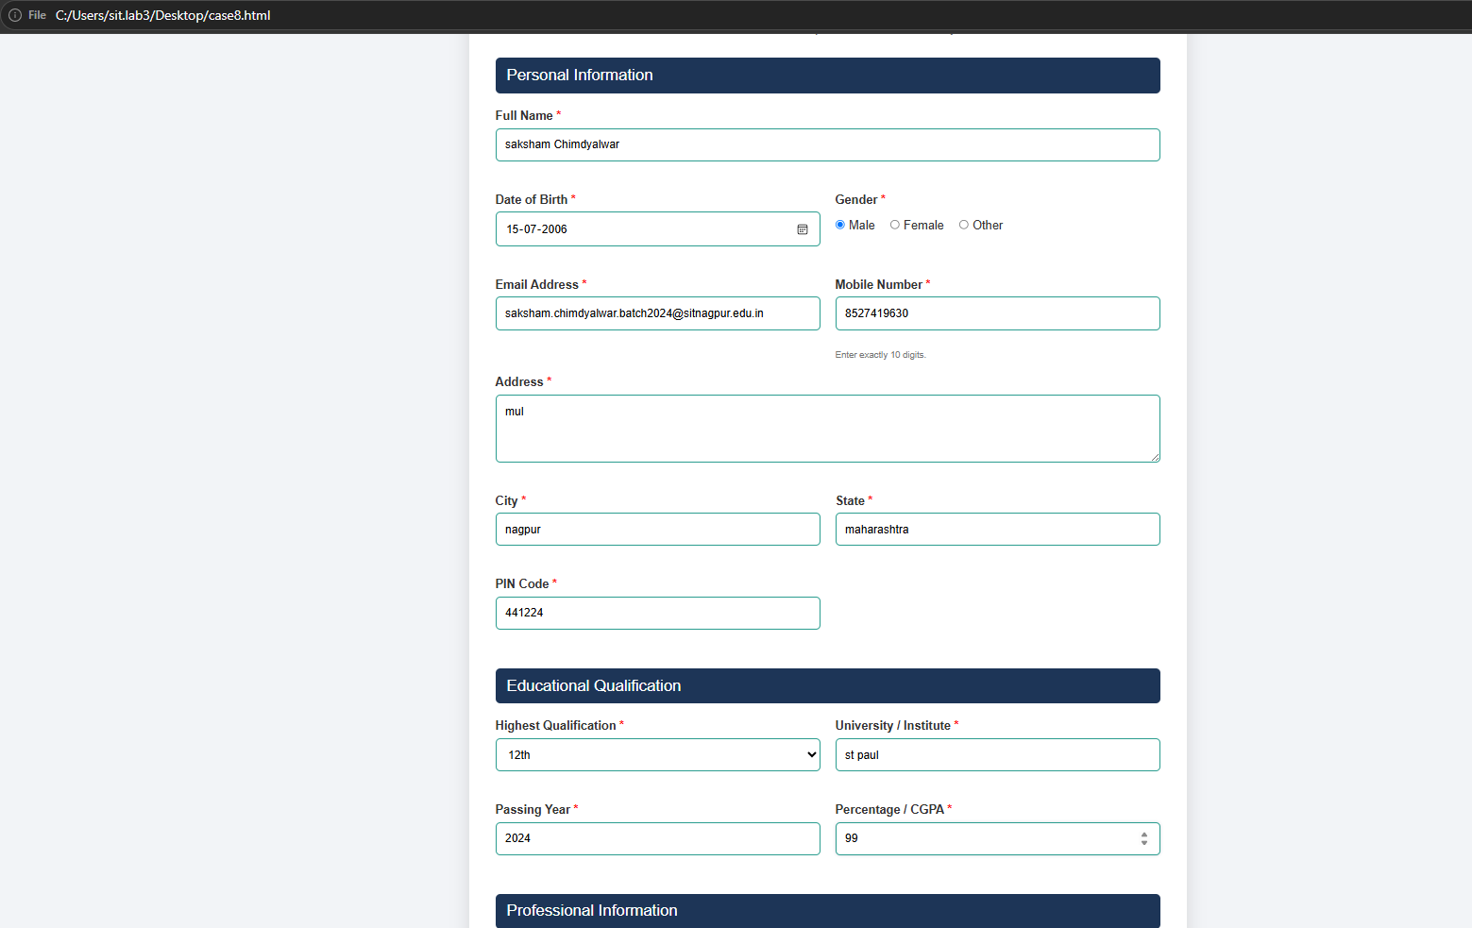

Experiment No. 9

Experiment Title: Implement Local Storage and Session Storage to save user preferences like theme settings.
- Software/Tools Required: VS Code, Html/JS Compiler…

Experiment Program Code:
<!DOCTYPE html>
<html lang="en">
<head>
<meta charset="UTF-8">
<meta name="viewport" content="width=device-width, initial-scale=1.0">
<title>Theme Preference Manager</title>
<style>
:root {
--bg-color: #ffffff;
--text-color: #333333;
--container-bg: #f5f5f5;
--border-color: #cccccc;
--btn-bg: #e0e0e0;
--btn-text: #333333;
}

[data-theme="dark"] {
--bg-color: #1e1e1e;
--text-color: #f5f5f5;
--container-bg: #2d2d2d;
--border-color: #444444;
--btn-bg: #444444;
--btn-text: #ffffff;
}

body {
font-family: Arial, sans-serif;
background-color: var(--bg-color);
color: var(--text-color);
display: flex;
justify-content: center;
align-items: center;
height: 100vh;
margin: 0;
transition: background-color 0.3s, color 0.3s;
}

.container {
background-color: var(--container-bg);
padding: 30px;
border-radius: 8px;
box-shadow: 0 4px 6px rgba(0, 0, 0, 0.1);
border: 1px solid var(--border-color);
text-align: center;
max-width: 400px;
width: 100%;
}

select, button {
width: 100%;
padding: 10px;
margin: 10px 0;
border-radius: 4px;
border: 1px solid var(--border-color);
font-size: 16px;
box-sizing: border-box;
}

button {
background-color: var(--btn-bg);
color: var(--btn-text);
cursor: pointer;
font-weight: bold;
transition: background-color 0.2s;
}

button:hover {
opacity: 0.9;
}

.status {
margin-top: 15px;
font-size: 14px;
font-style: italic;
}
</style>
</head>
<body>

<div class="container">
<h2>Theme Preference</h2>

<!-- 1. List to select theme -->
<label for="themeSelect">Choose a theme:</label>
<select id="themeSelect">
<option value="light">Light</option>
<option value="dark">Dark</option>
</select>

<!-- 2. Buttons to store preference -->
<button id="saveLocalBtn">Save to Local Storage</button>
<button id="saveSessionBtn">Save to Session Storage</button>

<!-- 3. Button to clear preference -->
<button id="clearBtn" style="background-color: #ff4d4d; color: white;">Clear Preferences</button>

<div class="status" id="statusMessage"></div>
</div>

<script>
const themeSelect = document.getElementById('themeSelect');
const saveLocalBtn = document.getElementById('saveLocalBtn');
const saveSessionBtn = document.getElementById('saveSessionBtn');
const clearBtn = document.getElementById('clearBtn');
const statusMessage = document.getElementById('statusMessage');

// Apply theme to document
function applyTheme(theme) {
document.documentElement.setAttribute('data-theme', theme);
themeSelect.value = theme;
}

// Check for existing preferences on page load
function loadSavedTheme() {
const localTheme = localStorage.getItem('userTheme');
const sessionTheme = sessionStorage.getItem('userTheme');

if (localTheme) {
applyTheme(localTheme);
statusMessage.textContent = "Loaded preference from Local Storage.";
} else if (sessionTheme) {
applyTheme(sessionTheme);
statusMessage.textContent = "Loaded preference from Session Storage.";
} else {
applyTheme('light');
statusMessage.textContent = "No saved preference found. Using default light theme.";
}
}

// Live preview when dropdown changes
themeSelect.addEventListener('change', (e) => {
applyTheme(e.target.value);
statusMessage.textContent = "Previewing theme... Save to keep changes.";
});

// Save to Local Storage (Persists even after closing browser)
saveLocalBtn.addEventListener('click', () => {
const selectedTheme = themeSelect.value;
localStorage.setItem('userTheme', selectedTheme);
sessionStorage.removeItem('userTheme'); // Clear session to avoid conflicts
statusMessage.textContent = `Saved "${selectedTheme}" to Local Storage (Permanent).`;
});

// Save to Session Storage (Cleared when tab closes)
saveSessionBtn.addEventListener('click', () => {
const selectedTheme = themeSelect.value;
sessionStorage.setItem('userTheme', selectedTheme);
localStorage.removeItem('userTheme'); // Clear local to avoid conflicts
statusMessage.textContent = `Saved "${selectedTheme}" to Session Storage (Temporary).`;
});

// Clear all saved storage preferences
clearBtn.addEventListener('click', () => {
localStorage.removeItem('userTheme');
sessionStorage.removeItem('userTheme');
applyTheme('light');
statusMessage.textContent = "Cleared all saved preferences. Reset to default light theme.";
});

// Initialize on load
loadSavedTheme();
</script>
</body>
</html>

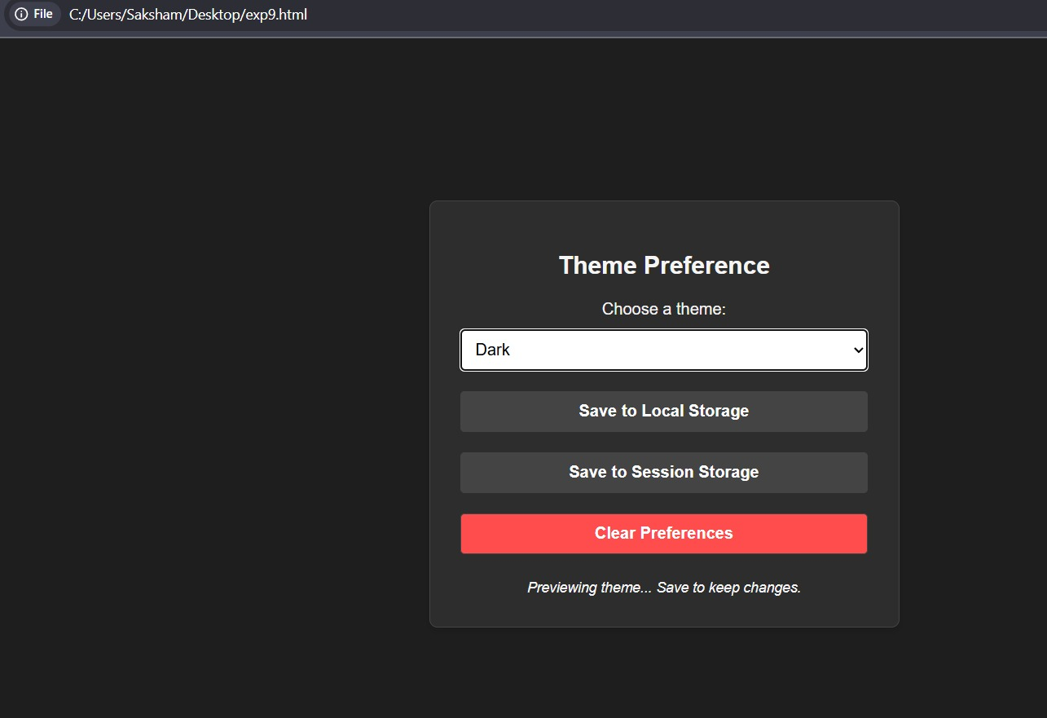

Experiment No. 10
  - Experiment Title: Load and display JSON data using fetch() and Querry$.getJSON(); render result dynamically in a table.
  - Software/Tools Required: VS Code, Html/JS Compiler…

Experiment Program Code:
<!DOCTYPE html>
<html lang="en">
<head>
<meta charset="UTF-8" />
<meta name="viewport" content="width=device-width, initial-scale=1.0" />

<title>Student JSON Data Table</title>

<style>
* {
box-sizing: border-box;
}

body {
margin: 0;
padding: 30px;
font-family: Arial, sans-serif;
background: #f1f5f9;
}

.container {
max-width: 950px;
margin: auto;
padding: 25px;
background: white;
border-radius: 12px;
box-shadow: 0 4px 15px rgba(0, 0, 0, 0.15);
}

h1 {
margin-top: 0;
text-align: center;
color: #1e293b;
}

.buttons {
display: flex;
justify-content: center;
gap: 10px;
margin: 20px 0;
}

button {
padding: 12px 20px;
border: none;
border-radius: 6px;
color: white;
cursor: pointer;
font-size: 15px;
}

#fetchButton {
background: #2563eb;
}

#jqueryButton {
background: #16a34a;
}

button:hover {
opacity: 0.85;
}

#message {
margin: 15px 0;
text-align: center;
font-weight: bold;
}

.success {
color: #16a34a;
}

.error {
color: #dc2626;
}

.table-wrapper {
overflow-x: auto;
}

table {
width: 100%;
margin-top: 20px;
border-collapse: collapse;
}

th,
td {
padding: 13px;
border: 1px solid #d1d5db;
text-align: left;
}

th {
background: #2563eb;
color: white;
}

tr:nth-child(even) {
background: #f8fafc;
}

tr:hover {
background: #e0f2fe;
}

@media screen and (max-width: 600px) {
body {
padding: 10px;
}

.container {
padding: 15px;
}

.buttons {
flex-direction: column;
}

button {
width: 100%;
}
}
</style>
</head>

<body>

<div class="container">
<h1>Student JSON Data</h1>

<div class="buttons">
<button id="fetchButton">
Load Using fetch()
</button>

<button id="jqueryButton">
Load Using $.getJSON()
</button>
</div>

<div id="message">
Click a button to load the data
</div>

<div class="table-wrapper">
<table>
<thead>
<tr>
<th>PRN</th>
<th>Name</th>
<th>Email</th>
</tr>
</thead>

<tbody id="tableBody">
<tr>
<td colspan="3">
No data loaded yet
</td>
</tr>
</tbody>
</table>
</div>
</div>

<!-- jQuery library -->
<script src="https://code.jquery.com/jquery-3.7.1.min.js"></script>

<script>
/*
* Sample JSON data for students
*/
const studentData = [
{
prn: "1151",
name: "Saksham Chimdyalwar ",
email: "sak@gmail.com"
},
{
prn: "1193",
name: "kanak Sawarkar",
email: "kanak@gmail.com"
},
{
prn: "1208",
name: "Arnav wandile",
email: "arnav@gmail.com"
},
{
prn: "1181",
name: "preetish notwani",
email: "preetish@gmail.com"
},
{
prn: "1206",
name: "siddhant virmani",
email: "siddhant@gmail.com"
}
];

/*
* Convert the JSON data into a temporary JSON file URL.
*/
const jsonBlob = new Blob(
[JSON.stringify(studentData)],
{
type: "application/json"
}
);

const jsonFileUrl = URL.createObjectURL(jsonBlob);

const tableBody = document.getElementById("tableBody");
const message = document.getElementById("message");

/*
* Render JSON data inside the table
*/
function renderTable(data) {
tableBody.innerHTML = "";

if (data.length === 0) {
tableBody.innerHTML = `
<tr>
<td colspan="3">No data found</td>
</tr>
`;
return;
}

data.forEach(function(student) {
const tableRow = document.createElement("tr");
tableRow.innerHTML = `
<td>${student.prn}</td>
<td>${student.name}</td>
<td>${student.email}</td>
`;
tableBody.appendChild(tableRow);
});
}

/*
* Display a loading message
*/
function showLoading(messageText) {
message.textContent = messageText;
message.className = "";
}

/*
* Load JSON data using fetch()
*/
document
.getElementById("fetchButton")
.addEventListener("click", function() {
showLoading("Loading data using fetch()...");

fetch(jsonFileUrl)
.then(function(response) {
if (!response.ok) {
throw new Error("Unable to load data");
}
return response.json();
})
.then(function(data) {
renderTable(data);
message.textContent =
"Data loaded successfully using fetch()";
message.className = "success";
})
.catch(function(error) {
message.textContent =
"Error: " + error.message;
message.className = "error";
});
});

/*
* Load JSON data using jQuery $.getJSON()
*/
$("#jqueryButton").on("click", function() {
showLoading("Loading data using $.getJSON()...");

$.getJSON(jsonFileUrl)
.done(function(data) {
renderTable(data);
message.textContent =
"Data loaded successfully using $.getJSON()";
message.className = "success";
})
.fail(function() {
message.textContent =
"Error: $.getJSON() could not load the data";
message.className = "error";
});
});
</script>

</body>
</html>

Output:

